


Implantable ports
An implantable port is a tube (catheter) with a small reservoir (port) attached to it. You can have chemotherapy and other drugs through the port and blood samples taken from it. It can stay in place until all your treatment is finished.  A doctor will insert your port, usually using a local anaesthetic. They insert the port under the skin, usually in your chest, and the attached tube goes into a large vein in your chest. | 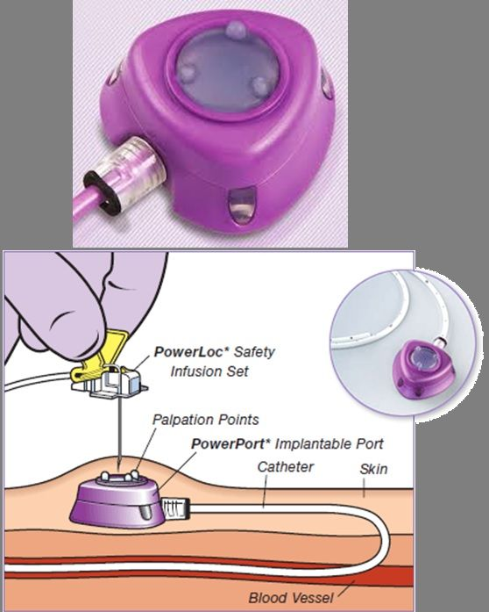
You can see and feel a small bump underneath your skin where the port is. A special needle is passed through your skin into the port to give your therapy into the vein. If it is not used regularly, the port is flushed every four weeks to stop it blocking. Contact the Velindre Treatment Helpline if there is redness, swelling or pain near or around the port, or if you don’t feel well. The telephone number is at the bottom of the second page. | 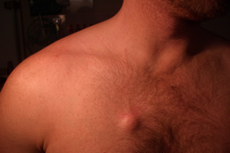
Will there be any tests before the port is put in?
Before the port is put in you will need to come into the hospital for blood tests and a routine MRSA screen. At this appointment a Doctor or Nurse will tell you about the port, how it is placed and what you need to do after it has been placed. You will be asked to sign a consent form. This appointment will be either in Velindre or in a local hospital – you will be informed of the date and time of this appointment and where to go.

How is the implantable port put in?

A specialist doctor will put your port in at a hospital. The hospital where the port will be placed depends on where you live. It will not be placed in Velindre. It is usually done in the operating theatre or the X-ray department. A local anaesthetic will be injected into your skin to numb a few small areas on your chest and neck. You might feel some pressure on your chest or neck during the procedure and you may feel some discomfort. You should inform the Doctor placing your port you have pain. You will usually be able to go home on the same day.
Two small cuts (incisions) will be made in your skin. The first is made to create a pocket under the skin for the port – this will be in your chest and will be about 3–4cm long. There will also be a smaller incision (1-2cm long) where the catheter is put into the vein (usually in the neck).
The port will be put under the skin. The catheter attached to the port will be tunneled under your skin to the smaller incision in the neck, where it will be put into a vein. The incision at the chest will be closed with a stitch (suture) these are usually dissolvable. The incision in the neck will be closed with a suture or a steri-strip. If the stitches are not dissolvable, they will be removed after about 7 to 10 days. A small dressing will cover the wounds for a few days after the procedure.
You may feel a bit sore and bruised for a few days after the port is put in. You can ask your doctor or nurse which painkillers you should take to help with this.

How the implantable port is used?
The port can be used soon after it has been put in. The skin is cleaned with anti-septic solution and then a special (non-coring) needle will be placed through the skin and into the port. This shouldn’t be painful, but you may feel a pushing sensation. You can have numbing cream if you wish which takes about 30-40 minutes to work. Treatment can then be given into the port, or blood samples can be taken from it. If you are having a routine flush or blood sampling only, the needle will be removed. For longer treatments, you will have a dressing placed over the needle to hold it in place until your treatment is finished. The needle is then removed. When the needle is removed, a small amount of fluid is flushed into the catheter so it doesn't get blocked. The port will need to be flushed every four weeks if it is not being used regularly.

Possible problems with implantable ports

Problem | Infection | Blood clot | Blocked line | Moved line
Symptoms | Redness, heat, swelling around the port or neck site. Feeling shivery or cold after the port has been flushed.  Temperature of 37.5 or over. | Swelling, tenderness, pain, redness or a change in colour of the neck chest or arm | Your nurse or doctor will not be able to get blood or flush the line. | The nurse may not be able to get blood from your port or the port has flipped and the surface of the port feels smooth
Action: | Ring Velindre Treatment Helpline without delay! | Ring Velindre Treatment Helpline without delay! | Your nurse or doctor will manage | Your nurse or doctor will manage

How the implantable port is removed?
When you don’t need the port any more, it will be taken out. This is usually done by the doctor who placed your port. A local anaesthetic is used to numb the area and a small incision will be made over the port to remove the port and the catheter. They will gently pull the catheter out of the vein. The wound is then stitched and covered with a small dressing.

Other information about implantable ports
The port shouldn't interfere with your daily activities. It is best to avoid strenuous exercise for a few weeks after it goes in, so your body can heal. You can swim and wash normally after the wounds have healed. Don't let anyone use any other type of needle apart from the special ‘non-coring’ needle. You may want to wear a medical ID bracelet saying you have an implanted port.
Telephone number: Velindre Hospital Treatment Helpline: 02920 615888 ask for the Helpline.

