Applying a duoderm dressing to a PICC using ANTT (Aseptic Non-touch Technique).
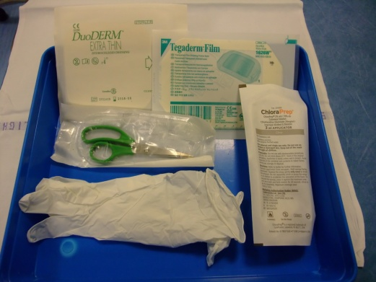 | 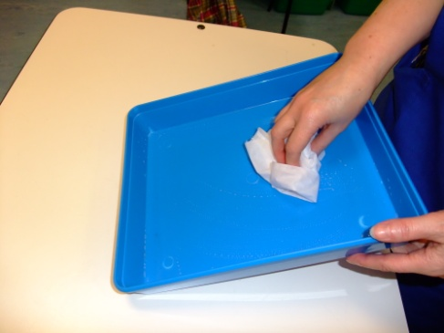 | 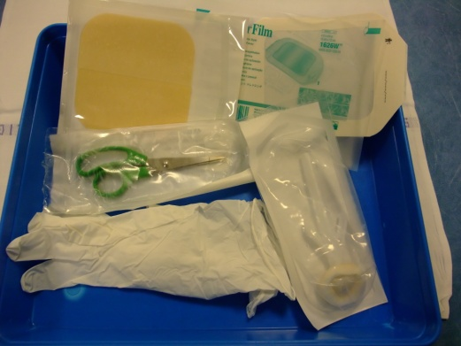 | 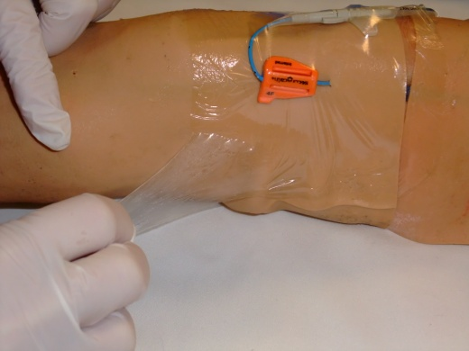
Need: Duoderm dressing; chloraprep sterile scissors; semi-permeable dressing:tegaderm/IV3000; gloves | 2. Wash hands thoroughly and clean tray with detergent wipes | 3. Open packaging of duoderm; scissors; semi-permeable dressing; chloraprepp in packaging onto tray. | 4. Put on non-sterile gloves and remove the PICC dressing.
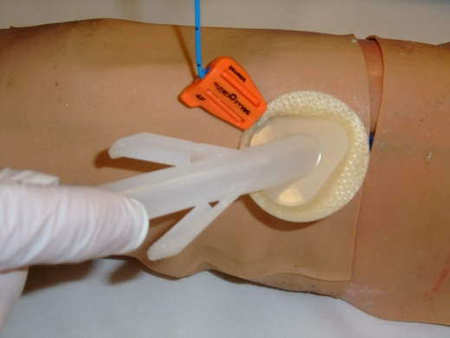 | 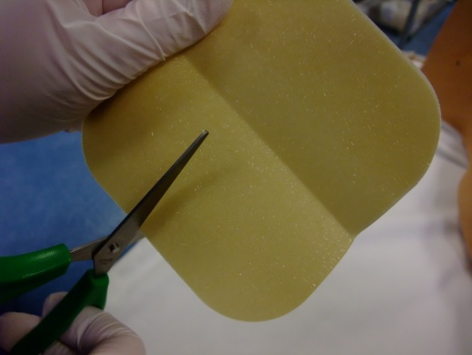 | 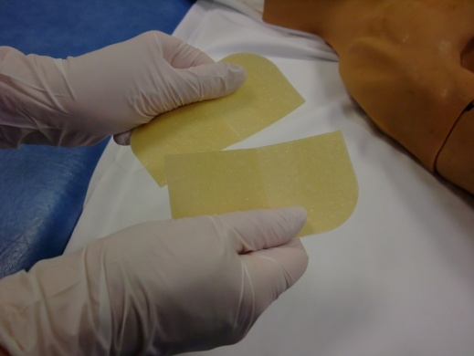 | 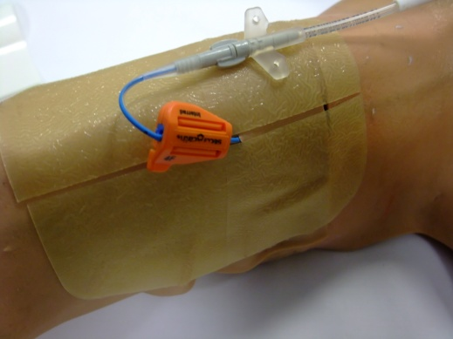
5.Clean the exit site with chloraprepp and allow to dry for at least 1 minute. | 6. Cut the duoderm in half in the opposite direction to the line. | 7. Make sure you cut the duoderm completely in half | 8. Place the two duoderm pieces on either side of the exit site
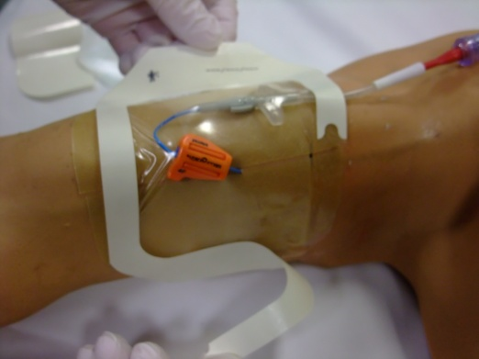 | 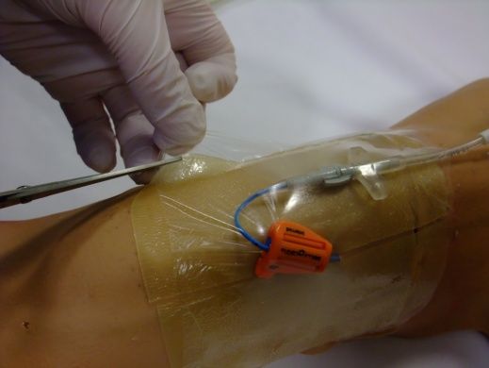 | 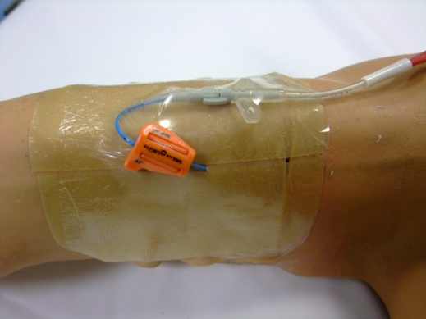 | Review the patient in 2-3 days.
9. Place the semi-permeable dressing over the duoderm. | 10. Carefully cut semi-permeable dressing away from the skin | 11. Ensure there is no semi-permeable dressing touching skin

