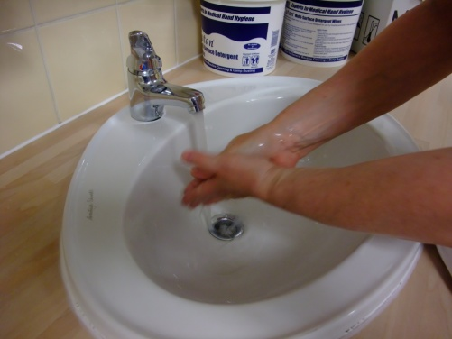 | 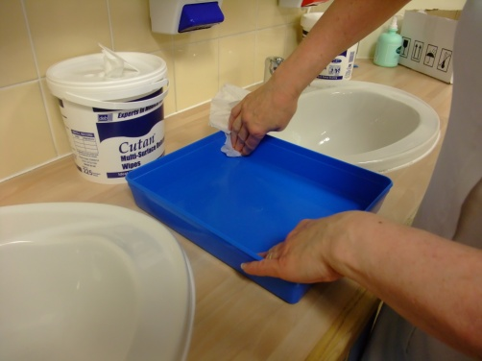 | 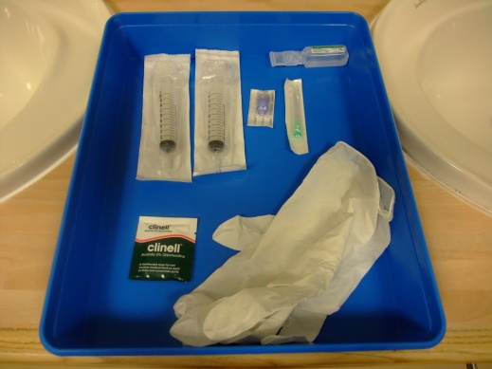 | 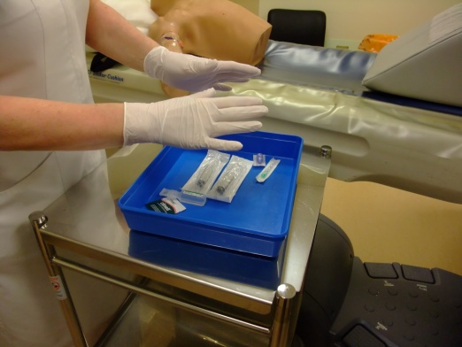
1. Assess the PICC for any signs of complications. Wash hands thoroughly. | 2. Clean a plastic tray with detergent wipes and leave to dry. | 3. Place unopened equipment in tray: 3 x 10ml syringes; clinell; end connector; saline; needle; gloves | 4. Put on non-sterile gloves
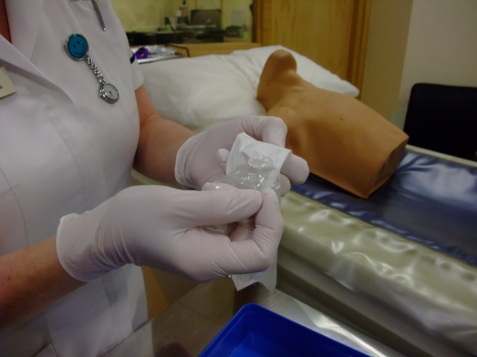 | 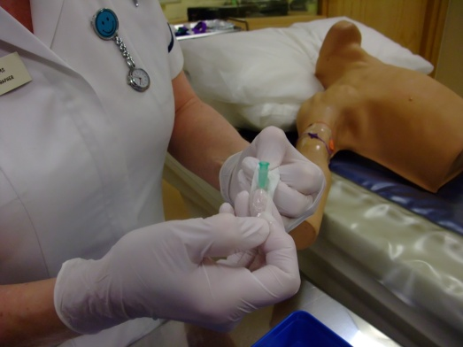 | 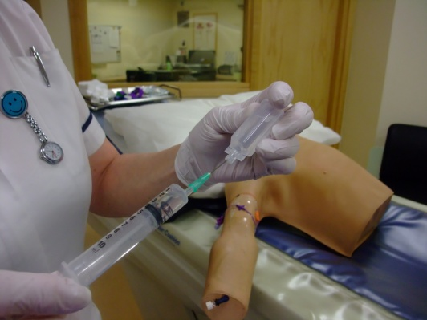 | 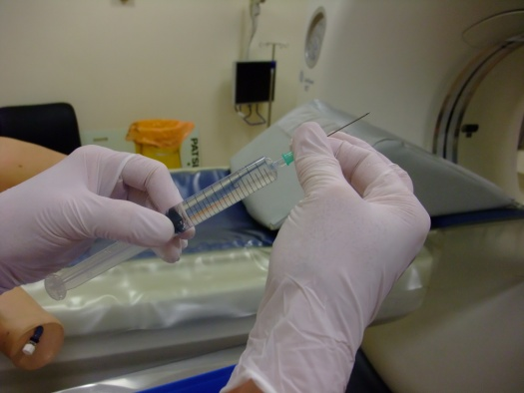
5. Open the syringe taking care not to touch the syringe tip. Keep syringe packaging in the tray. | 6. Open the needle taking care not to touch the end which is placed onto the syringe . Place the needle onto the syringe. | 7. Open vial of saline (check vial details 0.9% Normal Saline) and withdraw 10mls into syringe. DISPEL AIR! | 8. Remove needle without touching the end of the syringe and place directly into sharps bin
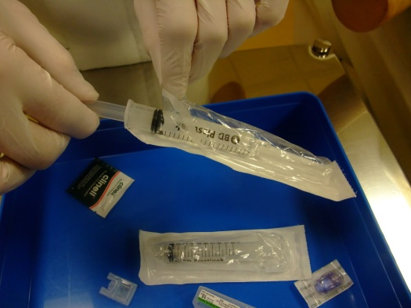 | 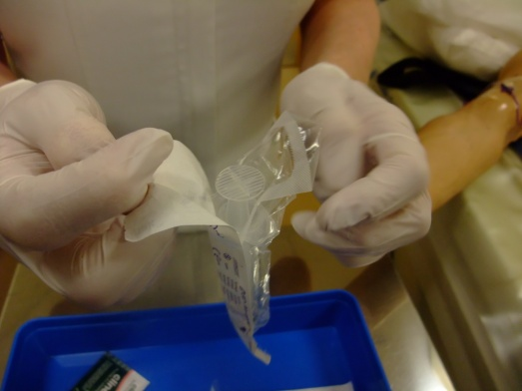 | 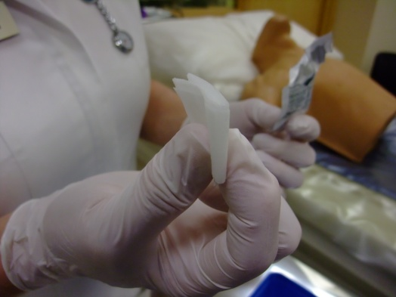 | 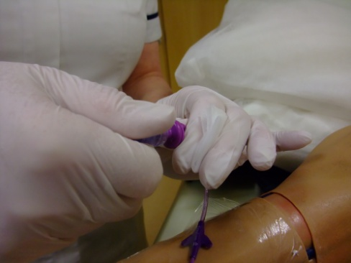
9. Place syringe back into package to protect the tip. Repeat from point 5 to draw up the other saline. | 10. Open the third 10mls syringe package slightly and place back into the tray. | 11. Open the clinell wipe but don’t open it out completely. | 12. Whilst holding the closed clinell in the palm of your hand, remove the end connector.

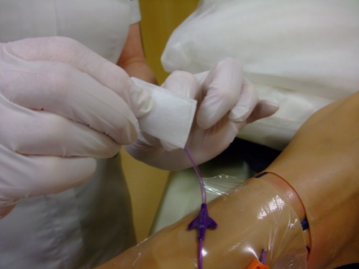 | 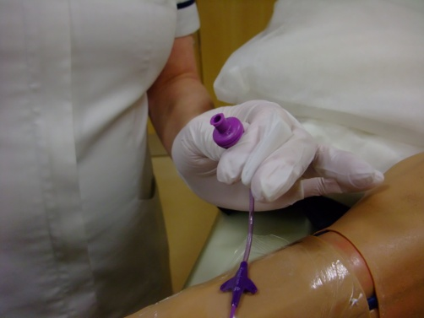 | 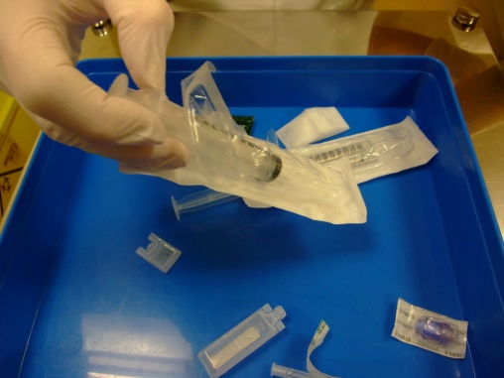 | 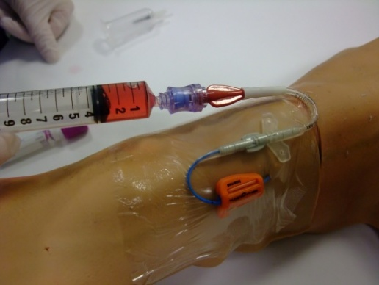
13. Open clinell, clean the end of PICC thoroughly with a part of the clinell that you haven’t touched. | 14. Allow to dry for 30 seconds. | 15. Whilst still holding the end of the PICC, take the empty syringe out of the packaging. | 16. Withdraw blood from the PICC. 1ml is sufficient. If blood present skip to point 19.
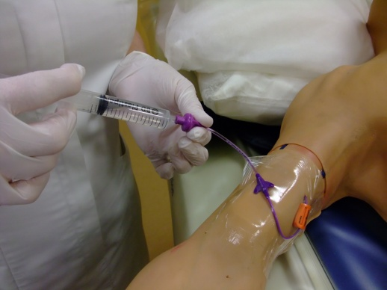 | 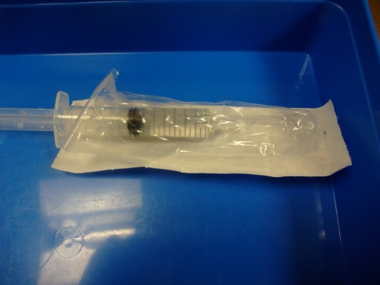 |  | 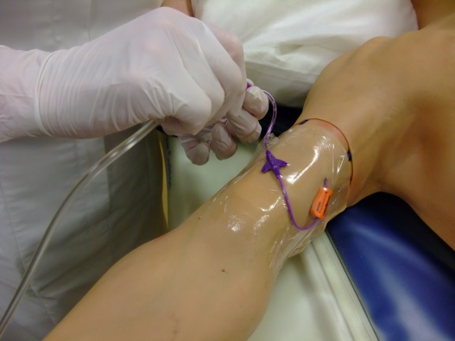
17. If NO blood return, flush with saline. NEVER USE PICC WITH NO BLOOD RETURN! | 18. Place filled syringe back in packaging if using to flush. Try again to get a blood return. | 19. After blood return is established, flush with the saline. | 20. Attach contrast line to the end of the PICC.
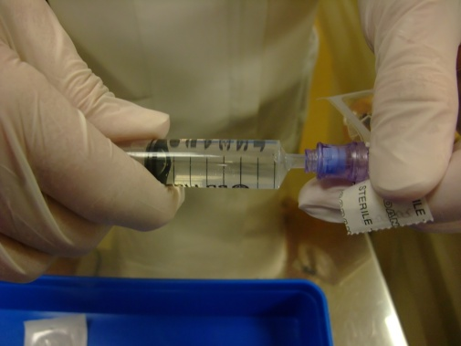 | 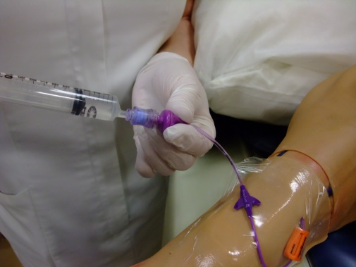 | Flush using turbulent positive pressure flush. Turbulent flush is when you use a push pause method whilst flushing and positive pressure is to keep flushing as you are removing the syringe at the end of the flush. | If you have an open ended PICC with a clamp, you must close the clamp each time there is no syringe or end connector on the end of the PICC and clamp as you are flushing the last ml of saline.
21. Post procedure, place a new connector onto the saline syringe. Take care not to touch key parts. | 22. Remove infusion line, place end connector and syringe onto end of PICC and flush:

