Administration of bolus tPA (Alteplase) brand name: Actilyse Cathflo into a PICC without a blood return

tPA (tissue plasminogen activator) or Alteplase is a fibrinolytic agent that breaks down blood clots. It is from the same group of drugs as urokinase and is licensed for use to resolve central venous catheter occlusion due to blood coagulation. This can be a total occlusion or a partial occlusion (not be able to obtain a blood return). There is a patient group direction for the Actilyse Cathflo. In order for staff to give this drug using the PGD their name must be on the PGD document (VCC intranet; clinical guidelines; policies and procedures; PGD’s bottom left hand side) – if not, the drug has to be prescribed on a drug chart prior to administration. To have your name on the PGD you must read these guidelines and the PGD and inform the IV Access Specialist who will place your name on the list.

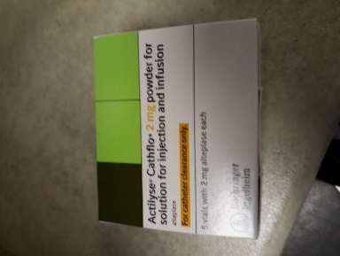 | Actilyse Cathflo needs to be stored in the FRIDGE between 2-8 degrees and ideally administered within 20mins of removal from the fridge.  In the box pictured to the left there are individual 2mg vials.

Do not proceed if the patient is allergic to alteplase, gentamycin or latex.

Caution to be exercised for the following:
  - Active internal bleeding
  - Any of the following within the last 48hrs: Surgery, percutaneous biopsy of internal organs or deep tissues.
  - Thrombocytopaenia
  - Any condition where bleeding is a significant hazard
  - The risk of hypersensitivity reactions may be increased in patient on ACE inhibitors
  - The risk of haemorrhage is increased in patients on other medications that inhibit coagulation (i.e. oral anticoagulants, heparin etc)

You do NOT need to use a 3 way tap for the bolus administration of Actilyse Cathflo when there is only a partial occlusion – i.e unable to get a blood return but can flush.

Equipment required: Procedure incorporating ANTT
Plastic tray
Non-sterile gloves
1 x 10ml syringe – luerlock!
Blunt needle
Vial of tPA (Alteplase) brand name Actilase Cathflo 2mg vial
1 x ampoule of sterile water for injection
2 x green clinell wipes
Needle free connector

Procedure:
- Wash hands.
- Clean the tray with clinell antiseptic wipes and leave to dry.
- Place unopened equipment into the tray: luerlock 10ml syringe, blunt needle, Actilase Cathflo vial, non-sterile gloves, ampoule of sterile water for injection, needle-free connector and 2 x clinell wipes.
- Put on non-sterile gloves.
- Remove the cap from the Actilase Cathflo vial and clean the bung with the clinell. Make sure to use a part of the clinell not touched by the gloves.
- Open the syringe & needle taking care not to contaminate key parts and draw up 2.2ml of the sterile water for injection.
- Reconstitute the Actilase Cathflo with 2.2mls of the sterile water for injection.
- Mix gently by swirling the vial until the contents are completely dissolved. DO NOT SHAKE!
- Slight foaming is not unusual, let it stand undisturbed to allow air bubbles to dissipate.
- Draw up 2ml of solution into syringe.
- The solution should be clear to a pale yellow solution.
- Place the syringe filled with Actilase Cathflo back into the syringe packaging or place a red end on the tip of the syringe to protect the key part.
- Remove the needle free connector from end of the PICC, clean the very end of the PICC with a clinell – clean with a part of the clinell you have not touched – leave to dry.
- Attach the syringe containing the Actilase Cathflo to the line and infuse the 2ml slowly into the catheter as a bolus.
- After 30 minutes, attempt to aspirate blood. If blood return is not present, flush the PICC and attempt to aspirate a blood return. Use all the techniques on the algorithm to obtain a blood return.
- If still no blood return, return to point 1 and repeat.

Administration of bolus tPA (Alteplase) brand name: Actilyse Cathflo into a PICC totally occluded PICC – unable to flush and no blood return!

tPA (tissue plasminogen activator) or Alteplase is a fibrinolytic agent that breaks down blood clots. It is from the same group of drugs as urokinase and is licensed for use to resolve central venous catheter occlusion due to blood coagulation. This can be a total occlusion or a partial occlusion (not be able to obtain a blood return). There is a patient group direction for the Actilyse Cathflo. In order for staff to give this drug using the PGD their name must be on the PGD document (VCC intranet; clinical guidelines; policies and procedures; PGD’s bottom left hand side) – if not, the drug has to be prescribed on a drug chart prior to administration. To have your name placed on the PGD you must read these guidelines and the PGD and inform the IV Access Specialist who will place your name on the list.

Actilyse Cathflo needs to be stored in the FRIDGE between 2-8 degrees and ideally administered within 20mins of removal from the fridge.

In the box pictured to the left there are individual 2mg vials.

Do not proceed if the patient is allergic to alteplase, gentamycin or latex.

Caution to be exercised for the following:
  - Active internal bleeding
  - Any of the following within the last 48hrs: Surgery, percutaneous biopsy of internal organs or deep tissues.
  - Thrombocytopaenia
  - Any condition where bleeding is a significant hazard
  - The risk of hypersensitivity reactions may be increased in patient on ACE inhibitors
  - The risk of haemorrhage is increased in patients on other medications that inhibit coagulation (i.e. oral anticoagulants, heparin etc)

Equipment required: Plastic tray; pair of non-sterile gloves; 2 x luer lock 10ml syringes; blunt needle, 3 way tap: green clinell wipe x 2; needle free connector, Vial of tPA (Alteplase) brand name Actilase Cathflo 2mg vial; 1 x ampoule of sterile water for injection

Procedure: Using ANTT principles:
- Wash hands. Clean plastic tray with clinell antiseptic wipes and leave to dry.
- Place unopened equipment into the tray: 2 x luer lock syringes, blunt needle, 3 way tap, Actilyse Cathflo 2mg vial, non-sterile gloves, sterile water for injection ampoule and 2 x clinell.
- Put on non-sterile gloves. Remove cap from the Actilyse Cathflo 2mg vial, clean bung with the clinell.
- Draw up 2.2mls of the sterile water and reconstitute the Actilase Cathflo powder.
- Mix gently by swirling the vial until the contents are completely dissolved. DO NOT SHAKE!
- Slight foaming is not unusual, let it stand undisturbed to allow air bubbles to dissipate.
- Draw up 2mls of the Actilase Cathflo solution into one of the 10ml syringes. Protect the tip in the syringe package.
- Prime the 3 way tap with Actilase Cathflo. Protect key parts – place in the tray. Remove the needle free connector, clean the end of the catheter with a clinell – leave to dry. Attach the primed 3-way tap to the end of the catheter.
- Close the 3 way tap to the patient: attach the syringe containing the Actilase Cathflo onto the three way tap at 3 o’clock and an empty syringe onto 6 o’clock (see picture below)
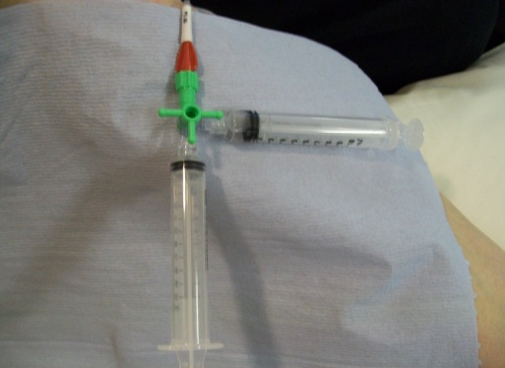
10.Turn the tap OFF to the Actilase Cathflo syringe (3 o’clock – picture below left), pull back on empty syringe (6 o’clock) to create vacuum in catheter to approximately 8-9mls and hold plunger at 8mls whilst at the same time turn the closed position onto the empty syringe (below right). A small amount of Actilase Cathflo will enter catheter.
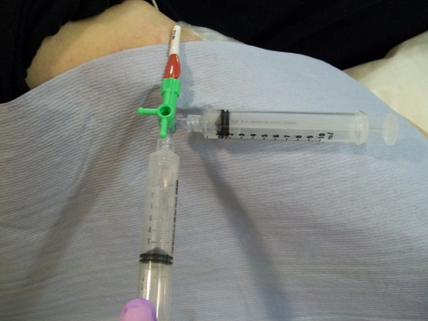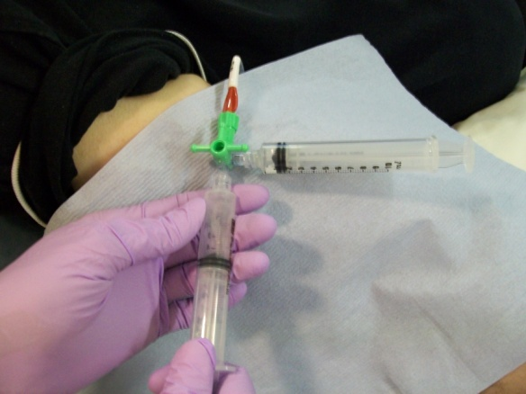
- Repeat procedure from point 6 another 3-5 times every 10 minutes or until Actilase Cathflo has been infused.
- After a total of 30 mins after the last attempt, try to withdraw the Actilase Cathflo lock and establish a blood return. If blood return present, flush with saline. If blood withdrawal is not present flush with saline and perform all the original steps from the algorithm to try to obtain a blood return.
- If still no blood return, give another dose of Actilase and start from point 1 again.

