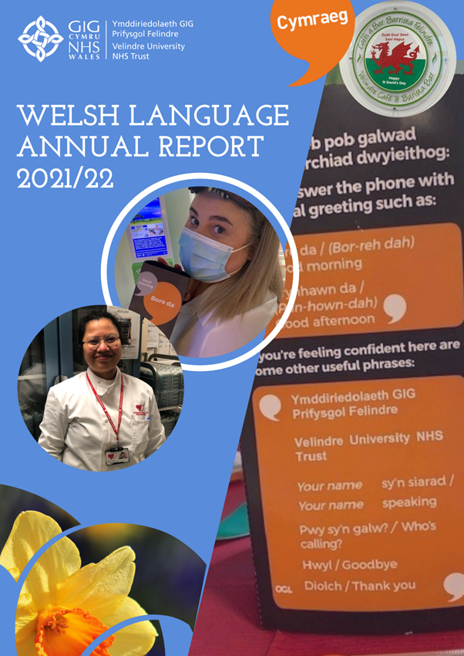
Welsh language Annual Report
2021-2022

Introduction
This report will focus on the importance the Trust gives to enhancing bilingual provision. It will demonstrate a commitment to the Welsh language standards but also highlight the work we are currently doing on our Welsh language Cultural plan, which is our platform for celebrating and recognising the cultural importance of Wales.
We continue to to provide support for the needs of our bilingual patients and donors. We are keen to ensure the services we provide are even more visible than previously especially at a time where the pandemic has made it difficult to communicate face to face.
We continue to strenthen the Governance around this area and recognise the importance of the Welsh language Standards but are also eager to do more than is required of us. We have began a Trust wide converstation this year on the meaning of Culture and have recognised that our values need to emulate what it means for our staff to provide a bilingual service under continued pressures that the pandemic has brought to us.
We value the work of our staff and at a time of continued change we seek to support them with all that they need to belong to an organisation with true values of Welsh language and Culture. The ethos of our new Cultural plan was accepted by the Executive Board and moving forward we will embace its aims and objectives and seek to further integrate our support for staff, patients and donors who need or chose to use the Welsh language.

Steve Ham
Chief Executive

Celebrating Welsh culture
The Trust continues to actively seek ways in which to engage its staff in the culture of Wales as well as its languages. We recognise the need to comply with its legal obligations but we aim to do more than is needed as this celebrates the diversity of our staff and services.
This reporting year we have drafted a Cultural Plan that aims to strengthen our engagement with staff around the language and Culture of Wales and promote a value of inclusion that encompasses all that we believe. Members of the Executive Team have taken on roles of responsibility for certain aspects of the Equality and Diverstity agenda and this includes an Ambassador role responsible for the Welsh language.
The Trusts draft Cultural plan aims to be as inclusive as possible with Trust leadeship driving the ethos of this plan throughout the work of the organisation.
Strengthening the Governance
Welsh language Standards Compliance
As of November 2021 our Trust compliance with the Welsh language Standards was at over 50%. This evidence is collected through our internal divisional working groups and reported to our Trust wide Welsh language development group. It is our way of ensuring we can build on the regulated compliance year on year and put projects in place to ensure we focus our provision productively.
Patient and donor correspondence
We previously reported on a systematic approach to ensuring our patient correspondence was bilingual. Since last year this has been put on hold in a number of areas as the development of a new system which generates the letters has been put on hold. All development initiatives were ceased due to the pandemic and the roll out of the new patient system has also been slower than anticipated.
As a Trust we are determined to ensure our bilingual correspondence is accessible and although at the Welsh Blood Service this is a process historically followed we have some way to go to ensure Velindre Cancer Centre are in line with our ambitions.
One of our departments is leading the way in this. Radiotherapy has translated and are using biligual letters as standard and they have also ensured that reception is supported by Welsh speaking triage staff as the number of Welsh speaking reception staff continues to be low. This is a positive way to ensure a department is supported when needed by other members of staff which is the ethos that underpins the ‘More Than Just Words’ framework.
Responding to telephone calls to the Trust in Welsh is extremely challenging. At the Welsh Blood Service this is more achievable. In this reporting year, 1004 calls in the medium of the Welsh Langauge were made to the Donor Contact Centres. We were able to respond to these calls in Welsh. This is 2% of the overall calls received.
Our Welsh language working group at Velindre Cancer Centre will take the monitoring of this on board as a matter of urgency this reporting year.

Meetings
In light of the continued change to working arrangements under the pandemic it has been necessary to think of ways in which we can internally support bilingual staff at meetings if they wish to use the Welsh language.
For external meetings we continue to be mindful of the ongoing work underway by Welsh Government with Microsoft in respect of the use of Microsoft Teams and look forward to hearing how this progresses over the coming months. Internally we are piloting a method of language identification within MS Teams (at the Welsh Blood Service) and will monitor the take up of this. The process will then be diseminated Trust wide as an option for language identification at internal meetings.

Recruiting Welsh speakers
As we stated in last’s years report our aim in this reporting year was to finalise our recruitment and language assessment process. We have completed this and are now ensuring that ALL posts going out for recruitment complete a language assessment table that is discussed with the Welsh language manager should questions arise. It has taken some time to integrate this process but we are confident that this will change the way in which we assess the need for language skills, not only as part of the individual post but for the wider teams across the Trust.
The process is in its infancy but will over time give us the data we need to evaluate its success.
As you will see from the figures below the pandemic has placed clinical priorities over language needs and we will be monitoring the increase in the number of ‘essential’ roles once the recruitment process has embedded.
Moving forward we will also be looking at the translation of our adverts and supporting materials. This will continue in 2022/23.
Velindre University NHS Trust 2021-2022
Total number of vacancies advertised as:
Welsh language skills are essential | 1
Welsh language skills are desirable | 98
Welsh language skills need to be learnt when appointed to the post | 0
Welsh language skills are not necessary | 6
Total Number of vacancies advertised 01/04/2021 to 31/03/2022 | 105
Welsh Blood Service 2021-2022
Total number of vacancies advertised as:
Welsh language skills are essential | 0
Welsh language skills are desirable | 97
Welsh language skills need to be learnt when appointed to the post | 0
Welsh language skills are not necessary | 1
Total Number of vacancies advertised 01/04/2021 to 31/03/2022 | 98

Velindre Cancer Centre 2021-2022
Total number of vacancies advertised as:
Welsh language skills are essential | 0
Welsh language skills are desirable | 269
Welsh language skills need to be learnt when appointed to the post | 0
Welsh language skills are not necessary | 23
Total Number of vacancies advertised 01/04/2021 to 31/03/2022 | 292

Communication
Translation
The Trust has committed additional financial resources to translation and we now have two dedicated translators to support our work. We also have a translation agreement with one of our hosted organiations for additional support when needed.
This has meant that we can focus our translation priorities and has enabled us to begin to translate important documentation such as Job descriptions and build a bank of dedicated bilingual descriptions for future use.
Translation figures continue to demonstrate the commitment given by the Trust to provide bilingual internal and external information and services. This reporting year we have progressed with the purchase of memory software and are in the process of using this to ensure consistency with translaton and as a time saving resource. Liaising with our translation colleagues across the NHS we can move this forward again this year and share a productice reasource with other translation teams.
Websites
Work continues on the Trust Website and the Welsh Blood Service have updated their site in line with priorities and bilingual requirements. This year they have also developed a dedicated Welsh langauge page mirroring that of the Trust’s but specific to local requirements. The Promotion of this was extremely successful on St David’s day as was the celebration of its dedicated Welsh language working group.
1.12% (3,390) of the Welsh Blood Service website booking portal users (April 2021 to March 2022) have their browsers set in Welsh.
Overall, the Trust main website has received 3,200 Welsh language hits in the reporting year.

Welsh language Education
This year we have been actively promoting providing Welsh language training in the workplace. In addition to regularly advertising the opportunities provided by ‘Iaith Gwaith’ we have been supported by Cardiff University to run two courses for our staff.
Providing in house training is not as simple as ensuring financial support, it is crucial that staff are able to attend classes and are supported to do so. Unfortunately within a clinical setting this is not always possible, however, we are proud to announce that eight of our staff have successfully completed their first year and will be further supported by us to proceed to the next level of training.
Providing continued training and support to a small number of staff is more productive for the them and the needs of the services we provide. Our focus in the coming year is to further promote e-learning opportunities and a stronger in house support for those who wish to practice and become more confident in the work place.
We are pleased to note that the new Welsh language awareness package supported by the Welsh Government is now completed. The Trust has been eager to recieve this and will now be integrating this into its regular training Trust wide initiatives.
Welsh language Skills
We have increased our data entry compliance this year and are now showing an 84.5% compliance within ESR.
Collecting the language data is extremely important, however we are aware that even though our recruitment processess use this information to ensure future recruitment needs, we now need to use this data to enable us to strengthen our services further.
Workforce planning and our People Strategy are central to this, this states:
‘A Healthy and Engaged workforce, within a culture of true inclusivty, fairness and equality acoss the workforce. A workforce that is reflective of the Welsh population’s diversity, Welsh language and Cultural identity’
The Trust is demonstrating its commitment to ensuring the bilingual needs of its staff and services are central to planning at all levels and will continue this year to integrate these aims across the Trust.
 | Assignment Count | Required | Achieved | Compliance %
 | 1587 | 4761 | 4027 | 84.58%
Org L4 | Assignment Count | Required | Achieved | Compliance %
120 Corporate Division | 172 | 516 | 442 | 85.66%
120 Research, Development and Innovation Division | 51 | 153 | 137 | 89.54%
120 Transforming Cancer Services Division | 25 | 75 | 54 | 72.00%
120 Velindre Cancer Centre | 860 | 2580 | 2193 | 85.00%
120 Welsh Blood Service | 479 | 1437 | 1201 | 83.58%

Promotion
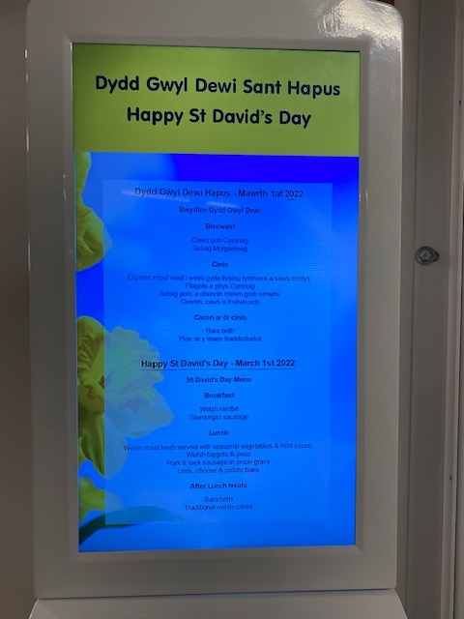
Our Trust wide promotion continues with celebrations such as ‘Diwrnod Shwmae / Sumae’ and St David’s day. This year we had an excellent colourful day at the Cancer Centre with a themed menu at the restaurant and a drop in opportunity for staff.
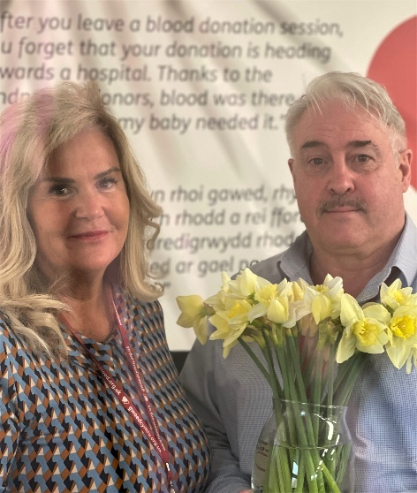
At the Welsh Blood service the launch of a dedicated Intranet page to assist staff was the main theme and an opportunity once again for staff to hear about the work of the Welsh language working group. It was also a great opportunity to congratulate the Welsh language learners who have completed the first year of their courses.

They will progress this coming year to a second level giving them opportunity to further develop their Welsh language skills.
Concerns and Complaints
The Welsh Blood Service
Three donor complaints were recieved by the Welsh Blood Service this reporting year.
The first two were relating to text messaging errors and the standard of Welsh sent and the other relating to a website error. Unfortunately an old message had been used and not a professionally translated message but this was rectified.
All three complaints were investigated thoroughly and as a consequence changes have been made to the service and checking processes.
None of the complaints resulted in a formal investigation being undertaken by the Welsh language Commissioner.
Velindre Cancer Centre
Patient Experience

During this reporting period, we have introduced a new digital feedback system at Velindre Cancer Centre. CIVICA Experience is a cloud-based insights platform which supports multi-channel survey data collection, real-time reporting, smart text analytics, workflow tools, event-driven alerts and push reporting. It was procured in 2021 as part of a Once for Wales exercise to support improvement across NHS Wales.

Capturing feedback from patients and their families in line with the National Framework for Assuring Service User Experience can now be conducted digitally and in real-time, enabling us to capture more data in a timely and responsive system. The CIVICA Experience implementation has seen an increase in survey responses and in particular Question 3 which references the Welsh language.

A total of 592 people answered the question “Were you able to speak Welsh to staff if you needed to?” with 5% of respondents saying “Never”. This equates to 30 patients who feel they were never able to use Welsh in Velindre. This powerful data is now informing our local improvement plans and will be used to continually monitor the impact and progress of service developments.
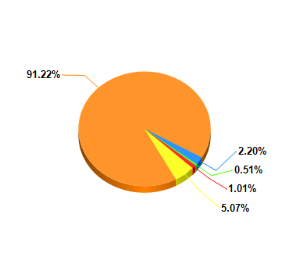

Hosted organisations
The Trust continues to host Health Technology Wales (HTW) and NHS Wales Shared Services Partnership (NWSSP). Both organisations are committed to ensuring the Welsh language standards are a high priority.
HTW have been actively translating Job descriptions in line with the requirements of the Welsh language standards.
NWSSP have ensured that staff across the NHS can now access the opening page of the Electronic Staff record system in Welsh and in English. This is a really positive step forward as the system has been monolingual since its inception. Being able to access personal employee information in the language of choice demonstrates a commitment to the language needs of the NHS employees.
Other areas of development have included:
- Translation Support Services
The Welsh Language Unit, in NHS Wales Shared Services Partnership have provided translation services for the following NHS organisations during 2021/22:
- NHS Wales Shared Services Partnership’s divisions and hosted programmes
- Public Health Wales NHS Trust
- Digital Health and Care Wales
- Velindre University NHS Trust
- Health Education Improvement Wales
- Wales Ambulance Service Trust in the translation of the 111 Website
- Welsh Health Specialised Services Committee
- The All-Wales Value in Health Care programme
- Supported NHS Employers in the translation of Job Descriptions and Person Specifications

Totalling over 3.7 million words translated during 2021/22.
- Translation Bank
The NHS is facing unprecedented demand for translation services, this is in response to meeting the requirements of the Welsh language standards in the most part, but also to respond to the need/demand amongst patients and the public.

It is becoming increasingly difficult to recruit qualified and experienced translators to full-time permanent vacancies, and it is also becoming challenging to retain staff, due to the recruitment market being extremely competitive.

To be able to respond to this situation we’ve established a bank of translators who can work flexibly for us as we require their services. The bank was established in autumn 2021, and our existing arrangements are working well to date. Our approach to agile working also means that we can recruit translators from different parts of Wales and beyond to assist us with our ability to respond to the demand for translation services.

- Student Streamlining
NHS Wales Shared Services have improved the customer journey through the Student Streamlining Service by ensuring the system provides a Welsh language journey throughout the process.

We audited and reviewed our processes, automated services and templates to ensure that there is now a seamless Welsh language offer to students engaging with our service.
As part of this project, we also translated adverts and job descriptions to enable Health Boards to be able to advertise the opportunities through the Student Streamlining programme through both the medium of Welsh and English.

- All Wales Patient Information Leaflets
We undertook a comprehensive audit and review of over 350 Patient Information Leaflets during 2021/22. The leaflets are given to patients as part of the consent process. The audit and review enabled us to make improvements to the language used in the leaflets, to have consistency in terminology as well as making the leaflets wholly bilingual for patients in Wales. Previously Welsh and English versions were available separately. This work will continue in 2022/23 with work being undertaken in partnership with Eido Healthcare to translate easy read versions of the leaflets.

- ESR Portlets available in Welsh
The Welsh Language Unit and the Workforce Information Systems team worked collaboratively with the NHS Business Services Authority and IBM on the development of Welsh Language Portlets on ESR in the autumn of 2021. This now means that the portals on ESR are available to NHS Staff in both Welsh and English to satisfy the requirements of Standard 81 of the Operational Standards.

- Contact Centre Review Project
The purpose of this review project was to audit our existing centre services, establish how our customers currently engage with us, identify improvements, and to increase and improve the self-serve element of the services we provide.

As part of this work, the Welsh language provision of services was also scrutinised, and a survey circulated to NHS staff identified that between 10% and 20% of NHS staff wished to engage with us through the medium of Welsh.

Further work will be undertaken with contact centres throughout NWSSP over the coming years.

- TRAC Recruitment system updates
We have continued to work with the developers of the TRAC system to ensure that the interface for the system continues to be up-to-date and consistent in both Welsh and English.

Moving forward
Over the coming year the Trust will revisit its Values and consult practively with its staff. Culture is central to these values and as we know a positive culture drives better care. We will be considering how we can further integrate our Welsh language and our divisional groups will take forward specific aims and objectives in order to strenghten provision locally.
Nationally we will continue to work with our partners, Local Health Boards and Welsh Government. The language and Culture of Wales belongs to us all and as a Trust we strive to provide the best bilingual care that we can.

