Welsh Language Annual Report
2023/24

Introduction
This report outlines the Trust’s key successes this year in moving closer to a seamless bilingual provision for our patients and donors. We have continued to work in line with the Welsh Language Standards and it has been a positive year, managing to integrate the needs of Welsh speakers further into the Trust’s aims and objectives. The NHS continues to face difficult times, however, we continue to strive for excellence in everything that we do.
Our divisional governance structures are well embedded and hold their own action plans relevant to the needs of the service, monitored and supported by the structure of the Welsh Language Standards and a central reporting network.
We continue to work in partnership with other Local Health Boards and Trusts to drive bilingual services forward and although we recognise that full compliance is not yet within our grasp, our commitment together continues. Partnership working and the sharing of best practice will ultimately support us to demonstrate that both the Welsh Language Standards and the More Than Just Words framework is at the forefront of our strategic planning.
As we plan for our new cancer centre and continue to improve our blood services we do so with the needs of a bilingual organisation and services in mind. Our workforce planning initiatives continue to support this agenda enabling us to pin point where the language gaps are in our teams.
This year we have increased the number of job descriptions being assessed for language needs and we are now assessing and discussing all positions as this opens up a dialogue with colleagues and strengthens an understanding as to why this provision is important to our patients and donors.
Our OD People Strategy aims to achieve ‘A workforce that is reflective of the Welsh population’s diversity, Welsh language and cultural identity’. We use this as a springboard for improvements in the cultural expression of Welshness and use of the language.

Steve Ham
Chief Executive
Velindre University NHS Trust

Service Delivery Standards
Green – High level of assurance
Yellow – Medium to high
Orange – low to medium level of assurance
Standards | Assurance rating
Correspondence (1,4,5,6,7)
Telephone services main numbers (8,9,10,11,12,13,14,15,16)
Telephone services direct numbers (16,17,18, 19)
Telephone automated systems (20)
Meetings (21,22, 22A, 22CH)
Public Meetings (26,27,28,29)
Displaying written material at public meetings (30)
Public Event (31,32,33,34)
Forms to be completed by individuals (36)
Documents available to individuals (37)
Documents and Forms (38)
Websites (39, 40, 41, 42, 43)
Apps (used on electronic devices) (44)
Social media (45,46)
Signage in publicly accessible areas (47,48,49)
Reception services (50, 52, 53)
Applications and documents for grants (54,55,56)
Invitations to Tender (57,58,59)
Promote Welsh language services (60-61)
Corporate Identity (62)
Public Address Systems (64)

A new Trust wide telephone Standard Operating Procedure was introduced this year, adding to the general guidance set out for staff assisting them with providing a bilingual service.
Telephone communication continues to be monitored and we have once again ensured current staff are fully aware of their responsibilities towards answering the phone bilingually. The Trust Welsh Langauge Manager has provided awareness raising sessions and managers have provided refresher training at the Cancer Centre to ensure compliance with the service delivery standards.
Continued improvement measures have been implemented and new, accessible telephony systems are included in plans for the new Cancer Centre.
We have worked closely with Cymraeg Gwaith to ensure confidence raising courses were offered to staff specifically responsible for communicating directly with patients and donors. We also ran an internal awareness raising class for relevant staff and provided one to one discussion opportunities for staff to ask questions relating to Welsh language correspondence.
We continue to promote our readiness to receive bilingual correspondence on our communication tools such as headed paper, the internet and social media. We welcome bilingual correspondence and will always reply to such correspondence in Welsh.
Our public board meetings are delivered using simultaneous translation and our Welsh speakers on the Board take advantage of this facility. The public are encouraged to observe the meetings and questions from the public are welcomed in both languages.
Our Trust website is fully bilingual and has been updated this year to ensure compliance with the Welsh Language Standards. The process of ensuring bilingual information is available to the public has evolved and now the functionality of the website platform enables us to recognise when and if information has been uploaded in one language only. This is a positive step forward as it allows us to monitor more proactively and provide training as and when needed to staff responsible for patient and donor information.
Over the last 12 months at the Welsh Blood Service the website has seen 236,462 total users, 233,447 (98.7%) English users, 2,727 (1.2%) Welsh users.
The Velindre University NHS Trust website has seen 103,000 visitors to the English side of the website and 1,500 (1.43%) visitors to the Welsh side of the website.
Signage continues to be updated at the Cancer Centre and the Welsh Blood Service. A recent audit of signage confirmed the need to advise on the process for providing time limited signage, such as daily events, and the operations teams worked closesly with the Welsh language team to ensure compliance. This process is being monitored via the divisional groups.
Our social media posts are delivered bilingually and all videos are provided with Welsh and English subtitles.
The tender process to identify a contractor to build the New Cancer Centre empahsised the requirement to comply with the Welsh language requirements. Communication with the Trust and the responsible teams has provided a clear understanding of bilingual processes. An Equality Impact Assessment which included an assessment of the impact on the Welsh language was agreed by our Executive team and is helping shape the new provision.
Welsh Blood Donor Awards
The Welsh Blood Service hold Donor Awards celebrating specific donor achievements or blood giving milestones. The Active Offer is provided here and an opportunity to say which language the donor would prefer prior to the event. Welsh subtitles are provided for the videos that are shown and introductions to the event are given bilingually.
To date, no one has requested the Welsh language however, the service is keen to continue with this as it demonstrates a commitment to the language needs of the donors.
Employee Excellence Awards
We held our Employee Excellence Awards virtually and in person in September 2023, promoting the event across the two divisional sites. The concept was developed bilingually from the outset and nominations were welcomed in Welsh and English. The Welsh language award for going the extra mile and using simple methods to promote the Active Offer at the Cancer Centre was given to the Radiology department.

The Welsh Language Board Champion congratulates the winner.

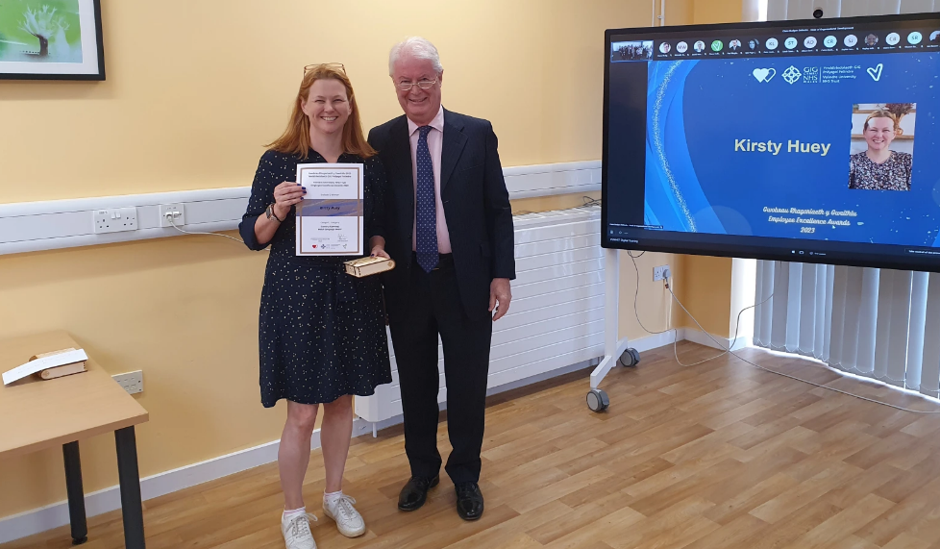

Again this year the Trust has promoted and celebrated a number of Welsh language events. Providing staff with an opportunity to celebrate Welsh culture is extremely important to us. Events such as ‘Santes Dwynwen’ and ‘St David’s Day’ are well represented and the staff are extremely proactive.
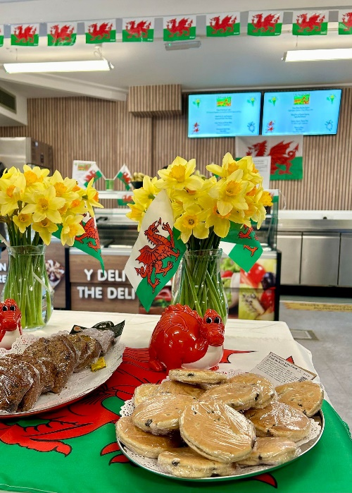
We had a special St David’s Day menu in the staff resturant at the Cancer Centre which generated a feeling of celebration. We also held a Trust-wide quiz giving staff the opportunity to test their Welsh knowledge of current and historical questions.

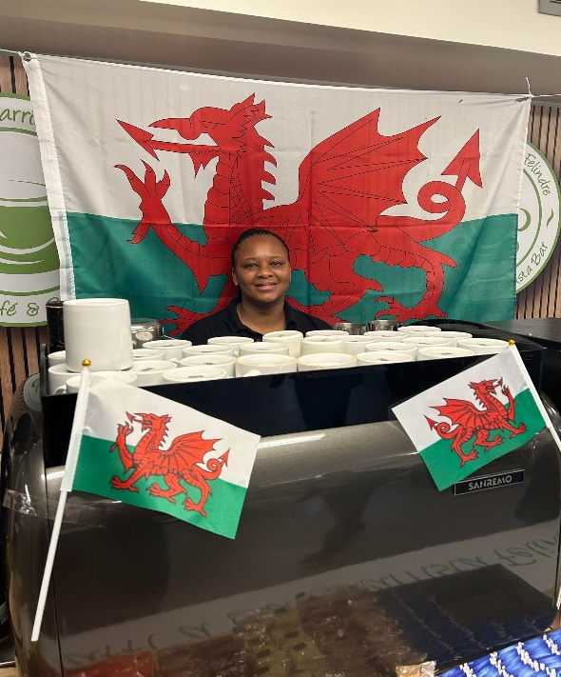
Translation
Again this year we have invested heavily in translation. We have two in-house translators and we have an extremely successful translation service level agreement with NHS Wales Shared Services Partnership.
Our translation figures continue to grow, which is a positive sign, meaning staff are becoming even more aware of the need to provide bilingual services.

Complaints and Official Investigations relevant to Operational Standards
Two complaints were received from the public this year, both relating to the accuracy of the Trust website.
This year we received from the Welsh Language Commissioner our first two official Investigations against compliance with the Welsh Language Standards. As with all complaints to the Trust, we take this very seriously and view it as an opportunity to learn.
Both complaints were specific to the Operational Standards, receiving telephone calls and being able to respond to them in Welsh and the Trust website. We have worked diligently to rectify internal processes.
An action plan has been developed as requested by the Welsh Language Commissioner and the actions within it are monitored by the Welsh Language Development Group. Divisional Welsh Language Groups feed into this process regularly.

Patient and donor feedback
We communicate regularly with patients and donors as part of our continuous improvement and this year, using our CIVICA system, it has been encouraging to note how many positive responses we’ve secured delivering our services.
braf gweld staff sy’n medru’r Gymraeg yn gwisgo bathodyn perthnasol (Melyn/Oren) I gydnabod hynny
Brilliant first experience giving blood and a big thank you and well done to all staff who spoke Welsh to me - brilliant.

Policy Making Standards
Green – High level of assurance
Yellow – Medium to high
Orange – low to medium level of assurance
Standards | Assurance rating
Formulating a new policy – opportunities and threats to the language (69)
New or revised policy – positive effects on the language (70)
New or revised policy – opportunites to use the language (71)
Publishing a policy or related document (72)
Publishing a consultation document and seeking views on the formulation of a policy (73)
Seeking views on a published consultation document (74)
Undertaking research to assist a policy decision and considering the effects on the Welsh language (75)
Commissioning of research to assist in a policy decision (76)
Commisioning of research to ensure no adverse effects or opportunities for the Welsh language (77)

Welsh Language Policy
Our internal Trust Welsh Language Policy was updated this year to reflect current expectations for continued compliance with the Welsh Language Standards.

Operational Standards
Green – High level of assurance
Yellow – Medium to high
Orange – low to medium level of assurance
Standards | Assurance rating
Welsh Language Policy – Using Welsh internally (79)
Contract of Employment (80)
Documents relating to employment of employees (81)
Policies relating to employment & workplace (82)
Complaints made by staff & disciplinary matters (83 – 88)
Computer software for spelling and grammar & interfaces (89)
Intranet pages (90 – 95)
Assessing Welsh language skills of employees (96)
Training for staff in key areas (97 & 98)
Opportunities to learn Welsh (99 – 103)
Email signatures, wording and Welsh language logo (104)
Welsh badges and branding for staff (105)
Assessing skills, advertising, recruiting (106 – 109)
Development and Publishing of a Clinical Consultation plan (110)
Signage & notices (113)
Recorded announcements (114)

Job descriptions
This year the Trust has worked diligently to ensure the process relating to bilingual job descriptions is strengthened.
The process begins with an assessment of language needs as part of the post and the wider departmental needs. This then provides the recruiting manager with a Welsh language ‘Essential’, ‘Desirable’ or ‘Willing to learn’ and the paperwork is then published bilingually.
It has been a long process however it has provided the Trust with a process that is now understood by recruiting managers and will be a continued focus for us as we plan our workforce for the year to come.
From March 2024, we are advertising any post that is directly responsible for ‘Reception’ as Welsh language ‘Essential’. As a Trust, we are aware that the language skills in these areas need to be strengthened and we are confident that this decision will suppport our future planning for these roles.
Since 2022 we have recruited more Welsh speaking staff into the Trust. Note – this data does not include hosted organisations (NWSSP and HTW).
Levels 3-5 Welsh language competencies have increased:
Level 3: 36 members of staff to 41
Level 4: 49 to 53 members
Level 5: 56 to 61

ESR
Recording the Trust’s language skills is again another way of supporting the needs of our workforce planning initiatives.
We have once again communicated the importance of this internally and have provided staff with the relevant information to do so. To date 88% of staff have recorded their Welsh language skills which is higher than last year.
As of March 2024, the Trust has 463 members of staff able to communicate on a level 1-5 in Welsh, that is 26% of the workforce.
The Welsh Language Awareness package within ESR has been completed by 84.31% of the Trust’s employees. This figure was noted at the end of March 2024.

Croeso 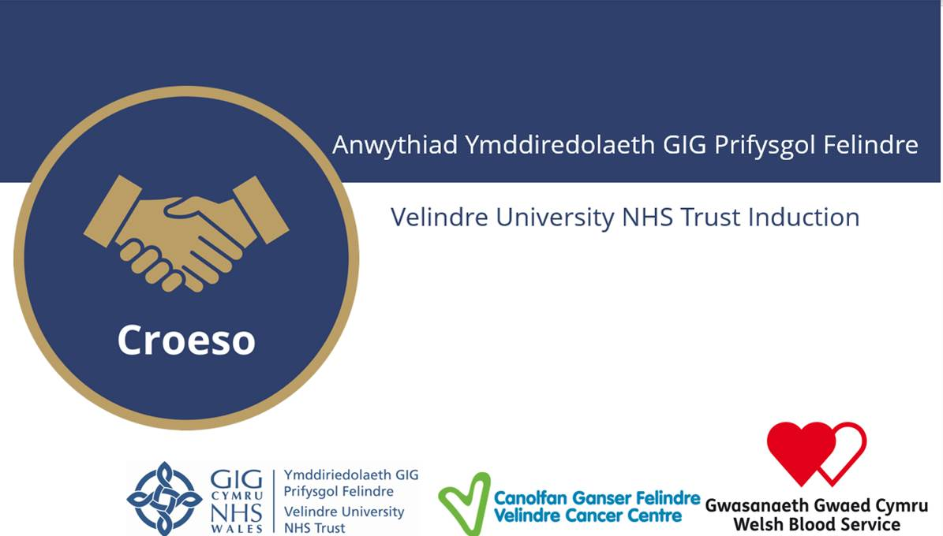

Our new staff corporate induction programme was developed this year. Developing an initiative with a bilingual voice from the outset has been a success and it continues to provide staff with opportunities to question and learn as they first enter the Trust.
Along with other important discussions such as Trust structures and Values, the Welsh language has a specific section and provides a platform for real discussion. It gives new staff a basic understanding of why bilingual services are valued and why the Active Offer is a concept to be exploited at every opportunity. Staff feedback has been positive and Welsh learning opportunities have been encouraged.
The programme has been running since July 2023 and 115 members of staff have completed the course.
Opportunities to learn Welsh
We are continuously looking at opportunities to support our staff in their continued professional development.
This year we were happy to hear of the additional funding available for the NHS to work in partnership with ‘Y Ganolfan Dysgu Cymraeg’. Our training provision began with a confidence raising course specifically tailored for the front line and reception staff. This is a pilot course and is being repeated in 2024 for other interested staff members.
Twenty-nine members of staff gave expressions of interest to follow the initial courses and discussions are underway regarding a Foundation level course for the end of 2024 onwards. The Chair of the Trust has also registered for a Foundation level course.
Intranet
A new Welsh language intranet page has been created this year, giving staff a one stop shop to all things relevant to supporting a bilingual service.
Our recruitment figures below highlight our focus on reception posts. We acknowledge that more work needs to be done to foster a greater understanding of bilingual language assessments, however the process has now been embedded and our proactive work continues.
Velindre UNHST (Corporate function) 2023-2024
Total number of vacancies advertised as:
Welsh language skills are essential | 1
Welsh language skills are desirable | 114
Welsh language skills need to be learnt when appointed to the post | 0
Welsh language skills are not necessary | 5
Total Number of vacancies advertised 01/04/2023 - 31/03/2024 | 120

Velindre Cancer Centre (VCC) 2023-2024
Total number of vacancies advertised as:
Welsh language skills are essential | 2
Welsh language skills are desirable | 280
Welsh language skills need to be learnt when appointed to the post | 0
Welsh language skills are not necessary | 7
Total Number of vacancies advertised 01/04/2023 - 31/03/2024 | 289
Welsh Blood Service (WBS) 2023-2024
Total number of vacancies advertised as:
Welsh language skills are essential | 2
Welsh language skills are desirable | 95
Welsh language skills need to be learnt when appointed to the post | 0
Welsh language skills are not necessary | 1
Total Number of vacancies advertised 01/04/2023 - 31/03/2024 | 98

Trust Values
This year the Trust has undergone an indepth review of its current Trust values. The values have been with us since 2015 and the review and renewal of the values have been conducted bilingually from the outset. Providing staff with opportunities to respond in Welsh to surveys and developing language accessible in both languages.
Translation was not left to the end of process, rather it was a part of the overall development and this has significantly increased the positive outcome and the wording of the values. Involving Welsh speaking staff from the outset meant that both languages were treated equally.
The final values were accepted in January 2024.
Gofalgar  Rydym yn garedig, yn gefnogol, yn agos atoch ac yn dangos tosturi tuag at bawb | Proffesiynol  Rydym yn cyflawni ein hymrwymiadau ac yn ysu am welliant a rhagoriaeth, ac yn gwrando er mwyn dysgu | Parchus  Rydym yn ceisio deall safbwyntiau pobl eraill, rydym yn meithrin perthnasoedd â phartneriaid, ac rydym yn rhannu gwybodaeth yn agored ac yn dryloyw.
Caring  We are kind, supportive, approachable and show compassion to all | Professional  We deliver on our commitments and drive for improvement and excellence, listening in order to learn | Respectful  We seek to understand other people’s perspectives, we build relationships with partners, and we share information openly and transparently

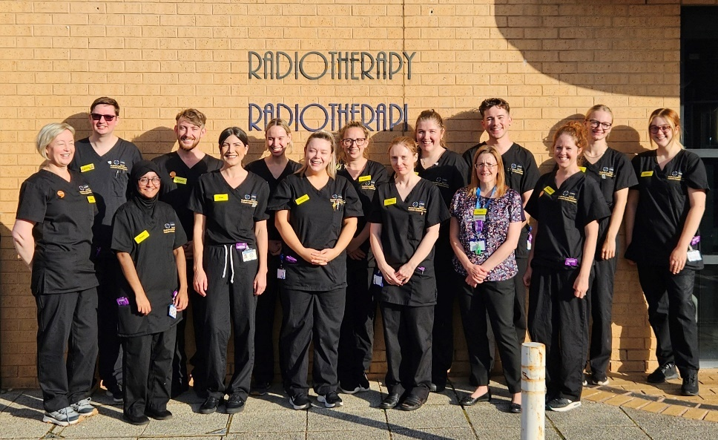
We continiously imporve our record keeping and evidence base for Welsh language services. It is clear that the Welsh Language Standards continue to be the driving force for provision. Externally we are recieving more demand for our services, however it is still very low and this year we have highlighted the need for a greater understanding of the Active Offer in order to support this demand. Small initiatives can make a difference.
Radiology and Radiotherapy at the Cancer Centre this year have highlighted their ability to provide a bilingual service by providing visual aids to patients identifying the Welsh speakers in the department and providing notice boards with current Welsh language information on them.

Record Keeping / Supplementary
We work proactively with other Trusts and Local Health Boards and this gives us a national vision of bilingual provision and offers a more meaningful discussion with the Welsh Language Commissioner through our reporting processes.
This year we have received two complaints relating to our Trust website. Both complaints were dealt with correctly and the issues were resolved.
Two formal investigations were received and both are ongoing with the process for reporting on progress via an action plan, being agreed by the Commissioner. Final submission of the action plan will be in January 2025 although the Trust is currently making the relevant changes to processes and the actions will be delivered prior to this submission date.
‘More than just words’ – Welsh Government framework
The reporting process for this framework sits outside of the Welsh Language Standards. Performance reports on progress are received by the Welsh Government and discussed at the Welsh language Partnership Board, charged with the monitoring of national progress.
Quarterly meetings with Welsh Government continue and best practice is shared. The Welsh Language Managers, working with Digital Health and Care Wales, have agreed an IT platform that will enable us to share national progress under this agenda. The platform is under development and will be accessible in the later part of 2024.
The Active Offer continues to be a focus for this framework and the Trust has provided training opportunites for staff to highlight this. Welsh Blood and its collection teams are currently looking at this and working with colleagues to highlight the needs as part of the blood collection process.
Hosted Organisations
Health Technology Wales
Health Technology Wales (HTW) are hosted by VUNHST and therefore work in line with the VUHST and Welsh Language Commissioner’s Office policy/standards. HTW currently receive Welsh Language translation support from VUNHST’s Translation Team, LfB Cymru, NWSSP and Trosol.

HTW, with support from VUNHST, maintain a Welsh Language policy action log which is reviewed with the necessary actions taken to ensure it meets with VUHST Welsh Language compliance.

HTW have published five new Standard Operating Procedures (SOP) in relation to:

- Welsh Language Staff compliance
- Roles and responsibilities for Welsh Language Standards
- Guidance on Welsh Language Standards for Welsh speaking members of HTW
- Welsh Language Services within recruitment processes
- Identification of language preference

In collaboration with the VUNHST Welsh Language Manager, HTW continue to ensure that its Standard Operating Procedures remain compliant with Welsh Language Standards.

Staff members within HTW are encouraged to develop their Welsh Language skills by undertaking Learn Welsh Cymru training. In addition, Welsh Language themed virtual coffee breaks are being introduced to encourage staff to develop their Welsh Language awareness.

Having recently updated its website, HTW have ensured web content is accessible in both English and Welsh and provided access to justification papers where necessary.

NWSSP
The organisation’s Annual report can be found on its Website but highlights can be found below:
Opportunities to learn Welsh:
NWSSP currently has a provider to host Welsh language courses to its staff.
The courses that were hosted in 2023/24 were as follows:
Course Level | Number of staff enrolled onto the courses
Entry Level 1 | 45
Entry Level 2 | 10
Foundation Level 1 | 4
Intermediate Level 1 | 3
Higher Level 1 part 2 | 5
Work Welsh Welcome part 1 | 12
Work Welsh Welcome back part 2 | 10

All courses are hosted during work time. The cost of the courses and coursebooks are covered by NWSSP as the employing organisation. As an employer, NWSSP actively promotes opportunities to learn Welsh to all NWSSP employees. NWSSP takes the good will approach to support staff to learn Welsh. NWSSP also promotes other applications to support staff to Learn Welsh, such as Duolingo and Say Something in Welsh.
Record Keeping Standards - Recording Welsh Language Skills on ESR - Standard 116:

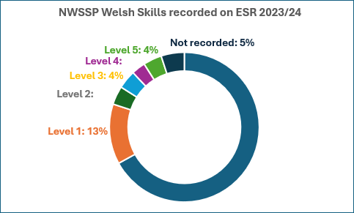
Record Keeping Standards - Advertising vacancies – Standard 117:
Total number of vacancies advertised as:
Welsh language skills are essential | 6
Welsh language skills are desirable | 445
Welsh language skills need to be learnt when appointed to the post | 0
Welsh language skills are not necessary | 0
Total Number of vacancies advertised 01/04/2022 - 31/03/2023 | 451

Translation services:
The demand for translation services continues to grow; in this financial year NWSSP translated over 5.5 million words and has processed in excess of 8.5 million words for the following organisations in 2023/24:
- NHS Wales Shared Services Partnership
- Velindre University NHS Trust
- Public Health Wales NHS Trust
- Digital Health Care Wales
- CVB - Llais
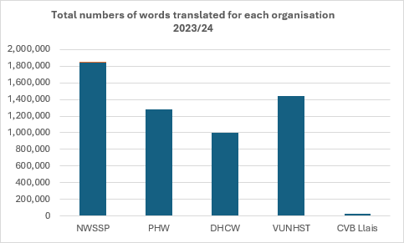

Moving forward
Processes are in place for a number of actions, however we are keen to ensure these processes provide us with outcomes that support our work and support our patients and donors. This will be our focus moving forward.
Ensuring we have a robust process in place to assess and recruit the need for Welsh language skills is crucial. The process has began but will take some time to embed. As a Trust we are aware that new systems are being developed nationally to look at this in a more robust way and we will be monitoring the developments of this system proactively.
We know that in order to provide bilingual services we need confident Welsh speakers. Training and IT systems are extremely important in order to make this a reality.
Standard 110, our Clinical Consultation plan, will also be revisisted as this has been highlighted as a national priority. Giving this greater scrutiny, and working with the network of Welsh Language Managers and the Welsh Language Commissioner, we will consider a more achievable standard around this area. We look forward to the achievments of the year ahead.

