Radium-223 dichloride FOI request – CORP 2022 – 101

Please see the below a Freedom of Information request:
Question 1
Please complete the table below:
Radium-223 dichloride service
Is radium-223 dichloride offered in your trust as a treatment for prostate cancer? (y/n) | Yes
If yes, please list the indications for which it is used in your trust? | 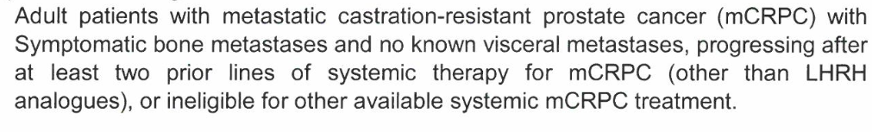

Question 2
Please detail the number of patients that are treated with radium-223 dichloride in your trust:
Velindre University NHS Trust can confirm it holds the relevant information in relation to question 2 of your request as shown in the table below. Please note the Trust is applying Section 40 (2) personal information for part of question, this is to protect the confidentiality of the patients involved, we have not given precise patient figures where the number was fewer than five.

Section 40 – Personal Information

Section 40 (2) of FOIA therefore applies as the release of the requested information within the public domain and in response to a FOIA request would constitute unfair and unlawful processing and it would be contrary to Data Protection law Principles and Conditions for the processing of personal data to disclose this information.

To place the Section 40 (2) exemption into context then the definition of personal data means data which relate to a living individual who can be identified.

(a) from those data, or
(b) from those data and other information which is in the possession of, or is likely to come into the possession of, the data controller

Because of the very low numbers involved in relation to the initial question then any further information requested would increase the likelihood of identification of that individual and so breach the Principles of Data Protection law.

This is an absolute exemption and so no public interest test applies

Patient numbers | Based on patients starting treatment in 2021
Number of prostate cancer patients completing treatment with radium-223 dichloride per year | 9
Number of prostate cancer patients initiating radium-223 dichloride treatment per year | 16
What is the average number of cycles administered per patient in your service? | 4.6
What is the waiting time before patients can receive radium-223 dichloride? | Within 2 weeks of request
How many patients are initiated with cabazitaxel per year in your trust? | ** Section 40 (2)

Question 3
In what department is molecular radiotherapy provided in your trust?
Administration | Radium-223 dichloride | 177Lutetium based radioligand therapy for neuroendocrine tumours
Nuclear Medicine | Y administration
Medical Physics
Radiotherapy
Oncology
Urology | Y ARSAC practitioner & referrers
Other
N/A |  | Not currently available

Question 4
What codes are associated with molecular radiotherapy administration in your trust?
NHS codes | HRG | OPCS code
Radium-223 dichloride |  | X65.7

Question 5
Please complete the table below:
Who performs the administration of the treatment? | Radium-223 dichloride | 177Lutetium based radioligand therapy for neuroendocrine tumours
CNS
Technician | Y
NM nurse
NM physicist
NM Consultant
Oncologist
Other (please state)

Question 6
Who holds the ARSAC licence in your trust?
Administration | (y/n) | Radium-223 dichloride | 177Lutetium based radioligand therapy for neuroendocrine tumours
Nuclear Medicine consultant
Clinical Oncologist |  | Y
Radiologist
Other (please state speciality)

Question 7
Do you provide Radioactive Waste Advisory, Radiation Protection Advisory and Medical Physics Expert services in your trust or are they outsourced?
Radiation safety (y/n) | Conducted in-house  (If so, please provide the number of full-time equivalents providing these services in your centre) | Outsourced
Radioactive Waste Adviser (RWA) | 0.2
Radiation Protection Adviser (RPA) | 2.2
Medical Physics Expert  (MPE) | 1.3

Question 8
Please complete the table below:
Dosimetry | (y/n) | If yes, what is the schedule after each administration? | If yes, is this analysed in-house or outsourced?
Is dosimetry performed for radium-223 dichloride prostate cancer patients? | N

