Ref: CORP 2022 - 055 Date: 15/06/2022
Dear ****

Request under Freedom of Information Act 2000

Thank you for your request for information in relation to physiotherapy services at Velindre, which we received on 28/04/2022.

Your Request and the Velindre University NHS Trust response:
is shown below;

Question 1: Please confirm how many whole time equivalent (WTE) physiotherapists, technicians and assistants, by Agenda for Change (AfC) band, were employed by Velindre NHS Trust (children & young people’s services and adult services) on the 31st of March 2022.

This should include any generic assistant or technical instructor posts that support physiotherapy service provision. Also, please note that physiotherapy staff work in a range of clinical settings. The answer to this request must also capture physiotherapy staff not directly line-managed by the head of physiotherapy services eg occupational health, community resource teams (CRTs).

VCC do not operate children and young peoples services, although some patients will fall into the young people category. Please find below the currently staff analysis.

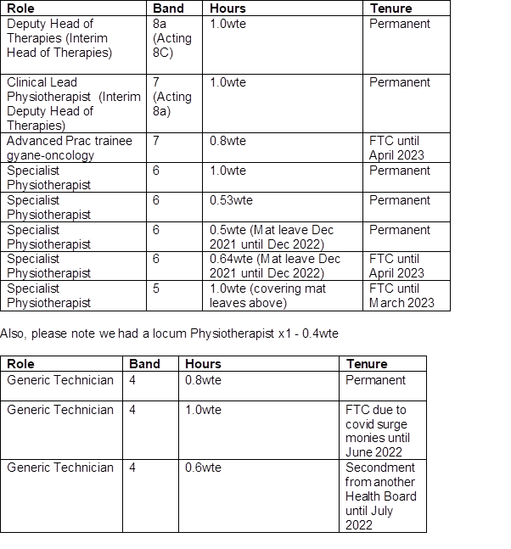

Question 2: Please confirm how many whole time equivalent (WTE) physiotherapist, technician and assistant vacancies were held in Velindre NHS Trust as of 31st of March 2022. The answer should identify the number of registered physiotherapists and the number of unregistered support staff as separate figures. Do not include admin and clerical.
There are currently no vacancies within the service.

Question 3: Please confirm or deny if Velindre NHS Trust has had any periods of time within the last 12 months to the 31st of March 2022 where recruitment to posts has been delayed? If confirmed, please provide reasons (short narrative) for the delay.
There have been no delays outside of the usual recruitment process.

Question 4: Please confirm or deny whether there have been any physiotherapy service developments in Velindre NHS Trust during the last financial year (April 2021 to end of March 2022).
If confirmed:
- Please provide details of the developments.
- Please confirm or deny whether these were supported by additional resources.

The Velindre Therapies Enhanced Discharge Service (V-TEDS) (WG Covid surge monies ended 31st March 2022) service is now part of Business as usual.

The Velindre Therapies Enhanced Discharge Service (V-TEDS) is a project which aims to provide the following service:
- To provide rapid community PT/OT interventions to patients discharged from FF ward and the Acute Oncology Assessment Unit (AOAU).
- To reduce (an in some cases prevent) the need for referral to existing community services.
- To enhance rehabilitation carry over by providing GTT contact time for patients who are waiting for community therapy services following discharge from Velindre Cancer Centre (VCC).
- To provide better continuity of care from hospital to home; ensuring good handover of inpatient interventions to relatives, patient support networks and/or community teams.

WECan Physical Activity Programme (core budget)
In collaboration with Newport Live, WECan is a virtual 6 week physical activity programme run by the physiotherapy team in partnership with Newport Live and NERS. It is available to any cancer patient wanting to become more physically active and enhance general health and wellbeing. Programme includes:
- Pre exercise assessment
- Online password protected webpage with access to prerecorded physical activity and wellbeing videos
- Optional live Q&A session weekly – held by the physiotherapy team
- End of 6 week programme review with physiotherapist and sign[posted to opportunities with NERS and Newport Live.

Gynae Oncology Advanced Practitioner post (3 years Charitable funded, until March 2023)
First Advanced Practitioner for Physiotherapy at Velindre cancer Centre.
This role is supported by the Gynae MDT , developments include
- Pre-habilitation clinic pre-radiotherapy.
- Pathway development
- Virtual Pilates group
- Patient resources
- Patient education
- Input into late effects of pelvic radiotherapy
- Collation of patient feedback /outcome measures

Neuro-oncology MDT (2 years WG funded through Transformational funds, ended 31st March 2022)
0.2wte Physiotherapist secured to be part of the neuro oncology MDT. The outpatient transformational bid financially endorsed by Welsh Government from July 2020 until the end of March 2022 has been utilised to provide a much needed extension to the neuro oncology patient pathway; to establish a virtual review clinic to support patients on and beyond treatment in an integrated and holistic MDT way. From extensive benchmarking, the clinic is the first of its kind in the UK and puts VCC at the forefront of delivering patient-centred and gold standard care. The joint review clinic meets a number of key aims of the Outpatients Strategy 2020-23, in particular;
- Reduces waiting times and delays to services,
- Reduces face to face outpatient appointments,
- Reduces DNAs across specialities,
- Symptoms managed in proactive way in a cohesive pathway.

Additional benefits of joint review clinic:

- Reduces travel for patients,
- Provides virtual working with patients and carers accessing the team from comfort of their own home,
- Avoids multiple hospital appointments with different AHPs at different times,
- Reduces fragmentation in care and unmet patient needs, crisis point management and inpatient hospital admissions (particularly pertinent with the current Covid 19 pandemic),
- Increases patient and carer experience and quality of life,
- Achieves VCC organisational benefits – putting the cancer centre at the forefront of innovative and gold standard care,
- Achieves a prudent working model with reduction in resource use and costs - from reduced outpatients appointments with multi-professionals

Question 5: Please confirm or deny if there have been any discontinued posts and/or services in the last year (April 2021 to end of March 2022). If confirmed, please provide details.
There have been no discontinued posts or services.

Question 6: Please confirm or deny if there has been any increase or decrease in demand for physiotherapy services in the last year (April 2021 to end if March 2022). If confirmed, please provide details.

Due to covid, reduced number of inpatient beds however increased complexity of patients coming through. Overall increase in demand from previous years:

2021/22
- New patients seen on inpatients = 309
- New patients seen in outpatients = 422
- New patients seen on the assessment unit = 292

Previous year submission of data:
Inpatients
• 2015/16 – 193
• 2016/17 – 248
• 2017/18 – 275
• 2018/19 - 249 new patients

Outpatients
• 2015/16 - 427 new patients
• 2016/17 – 614 new patients
• 2017/18 – 481 new patients
• 2018/19 – 173 new patients

Question 7: Please provide details of the level of budget increase or reduction made by the physiotherapy service in Velindre NHS Trust in the last financial year (April 2021 to end of March 2022) and what this is as a percentage of the physiotherapy budget.
Excluding pay award which would apply to all services, there was increase of 1.0 WTE Band 4 £30.5k, which is an 11.5% increase
Question 8: Please provide details of projected % budgetary savings to be made for this financial year (April 2021 to end of March 2022).
Savings targets are not directed at individual departments, the Division as a whole was targeted with a 1.8% target
Question 9: Please provide details of spend on agency/locum staff in the last year April 2021 to end of March 2022.
£30k of agency for physiotherapy services in 21/22 as described in question

I trust this answers your request for information, however, should you not be satisfied with the information supplied or the process of supplying it, you have a right to complain and request a review. You should forward your complaint to:-

Mr Ian Bevan via FOI.VUNHST@wales.nhs.uk
Head of Information Governance
Velindre University NHS Trust
2, Charnwood Court
Heol Billingsley
Parc Nantgarw
Cardiff / Caerdydd
CF15 7QZ
Tel / Ffon - 029 20196161

Should you wish to take your complaint further, if you are still unhappy with the decision after review, you can contact the:-

Information Commissioner's Office - Wales
2nd Floor,
Churchill House,
Churchill Way,
Cardiff,
CF10 2HH
Telephone: 0330 414 6421
email: wales@ico.org.uk

Yours sincerely,

Lauren Fear
Director of Corporate Governance and Chief of Staff
Velindre University NHS Trust
2 Charnwood Court
Heol Billingsley
Parc nantgarw
Cardiff
CF15 7QZ

