
VELINDRE NHS TRUST

GUIDELINES FOR THE MANAGEMENT OF ANAPHYLAXIS (v2)

This information is issued by the Medicines Management Committee on the understanding that it is the best available from the resources at our disposal at the time of preparation.

These guidelines are intended to support clinical judgment. The clinician must use his discretion when following them.
Written by: | VCC Resuscitation Practitioner (Naomi Osbourn)
Reviewed by: | Theresa Howe- Consultant  Deborah Connelly – Chemotherapy Outreach Nurse  Usman Malik – Principal Pharmacist  Cardiff and Vale Resuscitation Committee
Approved by: | Cardiff and Vale Resuscitation Committee  Medicines Management Committee  All Stake holders
Approved date: | March 2020
Review date: | March 2023

Guideline Version | Date re-written | Summary of amendments | Date approved
2.0 | March 2020 | Nil significant – Naomi Osbourn | March 2020

Contents
 | Page
Policy Statement | 3
Scope of Policy | 3
Aims and Objectives | 3
Definition of Anaphylaxis | 4
Recognition of Anaphylaxis | 4
Immediate Actions | 6
Emergency Treatment | 7
Observations | 8
Reporting | 8
Training | 9
Appendices | 10
References | 11

Policy Statement
The guidelines have been produced to ensure prompt recognition and treatment of anaphylaxis

Scope of policy
The policy applies to patients, staff and visitors to Velindre Cancer Centre who experience an anaphylactic reaction.

Aims and Objectives
The aim of these guidelines is to ensure the prompt recognition and treatment of anaphylaxis. These guidelines apply to all clinical staff that may come across an anaphylactic reaction and be expected to respond.
The guidelines apply to all patients, visitors or staff that attends Velindre Cancer Centre, which includes both adults and Children.
The Resuscitation Council has produced guidelines for the treatment and management of Anaphylaxis. They have produced a treatment algorithm and this should be followed by all staff at the Cancer Centre. (Appendix 1 )
The purpose of these local guidelines is to ensure that practices in relation to the treatment of anaphylaxis adhere to the Resuscitation Council guidelines. The guidelines have been produced to assist in the management of patients with Anaphylaxis and consider local procedures such as emergency response and transfer.

Clinical information
DEFINITION
Anaphylaxis is a severe, life-threatening, generalized or systemic hypersensitivity reaction
(Resuscitation Council 2008)
Anaphylaxis is characterized as rapidly developing life –threatening airway and/or breathing and/or circulation problems usually associated with Skin and mucosal changes (Resuscitation Council 2008)
Anaphylaxis can be triggered by a broad range of triggers which can include Antibiotics, anaesthetic drugs, other medications e.g. Chemotherapy, local anaesthetic, diamorphine, contrast media, latex, food, nuts, and stings. This list is not exhaustive. In some cases there may not be an identifiable trigger.

RECOGNITION OF ANAPHYLAXIS
Anaphylaxis is a life threatening emergency, it is often unexpected. The reaction may occur quickly within minutes of exposure to an allergen.
Anaphylaxis is likely when all 3 of the following criteria are met:
- Sudden onset and rapid progression of symptoms
- Life-threatening Airway and/or breathing and/or Circulation problems
- Skin and/or mucosal changes
Resuscitation Council (2008)

If a patient has a life threatening Airway, Breathing or Circulation problem administration of IM Adrenaline should not be delayed.
Patients can either develop an airway problem, breathing problem or circulation in isolation or develop a combination. The following are life –threatening symptoms and can indicate anaphylaxis

Airway
- Airway swelling – throat and tongue swelling. Patients may feel throat is closing up
- Hoarse voice
- Stridor – A high pitch inspiratory noise caused by upper airway obstruction.

Breathing
- Increased respiratory rate
- Wheeze
- Confusion due to hypoxia
- Cyanosis
- Respiratory arrest

Circulation
- Signs of shock – pale, clammy.
- Increased pulse rate (tachycardia).
- Low blood pressure (hypotension)
- Feeling faint, syncope or collapse.
- Decreased conscious level or loss of consciousness.
- Anaphylaxis can cause myocardial ischemia and chest pain
- Cardiac arrest.

Skin or mucosal changes
- Skin or mucosal changes can be subtle or absent in up to 20 % of reactions (RCUK 2008)
- Skin or mucosal changes can include:
- Erythema – patchy or generalized red rash
- Urticaria- hives, nettle rash or weals –pink or red in colour.
- Angioedema – involves deep swelling commonly swelling lips, eyelids and mouth

Other Symptoms
- Individuals may also experience vomiting, abdominal pain or incontinence
IMMEDIATE ACTIONS UPON SUSPICION OF ANAPHYLAXIS
An early call for help is essential for patients who have anaphylaxis or suspected of having anaphylaxis. A Medical Emergency Call -2222 should be placed.
Emergency Resuscitation equipment should be available including emergency medications.
The trigger/allergen should be removed immediately if possible and the patient assessed for using ABCDE approach please refer the anaphylaxis algorithm below
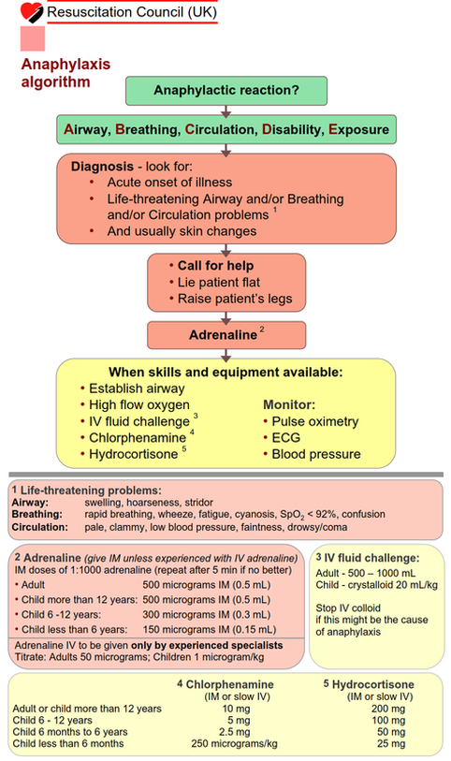
(Resuscitation Council 2008)

EMERGENCY TREATMENT FOR ANAPHYLAXIS
Adrenaline can be given without prescription. The Human Medicines Regulations 2012 allows certain drugs to be given without prescription for life saving purposes and this includes adrenaline 1:1000 for IM use in Anaphylaxis.

IV Adrenaline SHOULD NOT be given at Velindre Cancer Centre. IV adrenaline should only be given by Anaesthetists in monitored situations in Emergency Units and Critical Care.

Emergency Anaphylaxis kits are kept on each of the Resuscitation Trolleys and include:
- prefilled syringes of adrenaline 1:1000,
- Hydrocortisone
- chlorphenamine
- a copy of the Resuscitation Council Algorithm
Once the kit has been opened or used or kits have expired they need to be returned to pharmacy to replace.

Oxygen
All patients should receive high flow oxygen- 15L through a non re-breather mask.

Fluids
Infuse fluids rapidly as patients experiencing an anaphylactic reaction as patents are likely to lose fluid from their circulation and will experience vasodilatation, hypotension and signs of shock. Fluids should be administered through a wide bore cannula. A rapid fluid challenge of 500-1000mls should be given and response to fluid challenged monitored closely.

Anti-histamines
Anti histamines are a second line treatment used in anaphylaxis and should be administered following adrenaline as they can help reduce the effects of vasodilatation and bronchoconstriction.
Chlorphenamine is the recommended anti-histamine. Chlorephanamine can either be given via IM injection or slow IV bolus. The adult dose is 10mg
Steroids
Steroids are second line treatment used in anaphylaxis and may prevent prolonged reactions
Hydrocortisone is the recommended steroid. Hydrocortisone can be given via IM injection

Bronchodilators
Salbutamol and ipatropium inhalers can be given and should be considered.

Patient Position
All patients should lie flat if possible and raising the patient’s legs is recommended. Do not stand the patient up.

Treatment of children and visitors and members at Velindre
In the event of a visitor, member of staff or child developing an anaphylactic reaction or suspected anaphylactic reaction a medical emergency call should be activated as per emergency response protocol – dial 2222. A 999 emergency call also needs to be placed.
Paediatric adrenaline doses are clearly stated on the treatment algorithm and included in the appendices.
ALL PATIENTS WHO EXPERIENCE AN ANAPHYLACTIC REATION WILL REQUIRE TRANSFER TO UHW BY 999 EMERGENCY AMBULANCE.

OBSERVATION
All patients who have received adrenaline for anaphylaxis must be observed for a minimum of 6 hours and admitted overnight for observations. Patients who suffer anaphylaxis are at risk of developing a delayed second ‘biphasic’ reaction. Patients need to be monitored for any further biphasic reactions.

REPORTING OF ANAPHYLACTIC REACTIONS
Adverse drug reactions that include an anaphylactic reaction should be reported to the Medicines and Healthcare products Regulatory Agency (MHRA) using the yellow card scheme (www.mhra.gov.uk).
The British National Formulary (BNF) includes copies of the Yellow Card at the back of each edition.
A Datix form should be completed and details of the reaction documented in patient notes and CANISC.

TRAINING
Training for anaphylaxis is provided at Velindre and there are regular Anaphylaxis sessions provided. These are booked through the Electronic Staff Record System at Velindre.
All staff who attend Immediate Life Support (ILS) courses delivered by the Resuscitation Practitioner receive anaphylaxis training during the course.
Anaphylaxis training is also provided online through Learning@NHSWales, the learning platform for NHS Wales.
The Resuscitation Practitioner can be contacted if further training for individuals and departments is required.

APPENDIX
MEDICATION DOSES
Adrenaline (give IM unless experienced with IV adrenaline)
IM doses of 1:1000 adrenaline (repeat after 5 min if no better)

• Adult 500 micrograms IM (0.5 mL)
• Child more than 12 years: 500 micrograms IM (0.5 mL)
• Child 6 -12 years: 300 micrograms IM (0.3 mL)
• Child less than 6 years: 150 micrograms IM (0.15 mL)

Adrenaline IV to be given only by experienced specialists
Titrate: Adults 50 micrograms; Children 1 microgram/kg

Chlorphenamine
(IM or slow IV)
Adult or child more than 12 years 10 mg
Child 6 - 12 years 5 mg
Child 6 months to 6 years 2.5 mg
Child less than 6 months 250 micrograms/kg

Hydrocortisone
(IM or slow IV)
Adult or child more than 12 years 200 mg
Child 6 - 12 years 100 mg
Child 6 months to 6 years 50 mg
Child less than 6 months 25 mg

REFERENCES
Resuscitation Council UK (2008), Emergency treatment
of anaphylactic reactions, Guidelines for healthcare providers
Working Group of the Resuscitation Council (UK), London , Resuscitation Council UK.

Glossary of Terms and abbreviations

IM Intramuscular
IV Intravenous
ILS Immediate Life Support
UHW University Hospital of Wales
Datix Online incident reporting form
CANISC Cansic is an all Wales patient record used for the Clinical management of Patients.

