Ref: CORP 2021 - 089 Date: 19/08/2021
Dear ****

Request under Freedom of Information Act 2000

Thank you for your request for information relating to the number of Covid vaccines administered, discarded and/or thrown away within Velindre, which we received on 09/08/2021.

Your Request and the Velindre University NHS Trust response is shown below;

Please provide figures and information for the time period starting from when the UK vaccine-roll out began in December 2020 - Present.

- The total number of single Covid-19 vaccine doses administered by all health authorities within your trust each month, broken down by manufacturer, e.g. AstraZeneca, Pfizer and Moderna. - 13665 all COVID-19 (Pfizer Biontech)
- The total number of single vaccine doses that have been wasted or discarded at vaccine hubs controlled by your trust each month, broken down by manufacturer, e.g. AstraZeneca, Pfizer and Moderna. - See screenshot below
- Please state the reasons for this wastage or discarding, e.g. dropped or contaminated vials; human error in the preparation process; expired stock; leftover doses; and faulty syringes. - See screenshot below
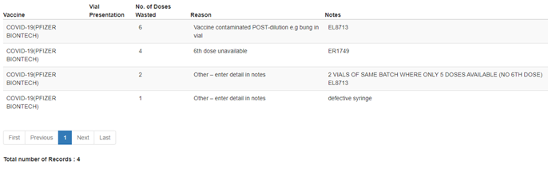

I trust this answers your request for information, however, should you not be satisfied with the information supplied or the process of supplying it, you have a right to complain and request a review. You should forward your complaint to:-

Mr Stuart Morris
Chief Digital Officer
Velindre NHS Trust
2, Charnwood Court
Heol Billingsley
Parc Nantgarw
Cardiff / Caerdydd
CF15 7QZ
Tel / Ffon - 029 20196161

Should you wish to take your complaint further, if you are still unhappy with the decision after review, you can contact the:-

Information Commissioner's Office - Wales
2nd Floor,
Churchill House,
Churchill Way,
Cardiff,
CF10 2HH
Telephone: 029 2067 8400
fax: 029 2067 8399
email: wales@ico.gsi.gov.uk

Yours sincerely

Julie Mann
Communication and Compliance officer
Velindre NHS Trust
2 Charnwood Court
Heol Billingsley
Parc nantgarw
Cardiff
CF15 7QZ

