Ref: CORP 2021 - 096 Date: 16/09/2021
Dear ****

Request under Freedom of Information Act 2000

Thank you for your request for information relating to costs incurred by the new Velindre Cancer Centre development since 2015, which we received on 19/08/2021.

Your Request and the Velindre University NHS Trust response is shown below;

- Values for the costs incurred by the new Velindre Cancer Centre development since 2015
£23,923m

- Summarised breakdown of costs by categories
As per breakdown below

- Breakdown of costs incurred by financial year
As per breakdown below

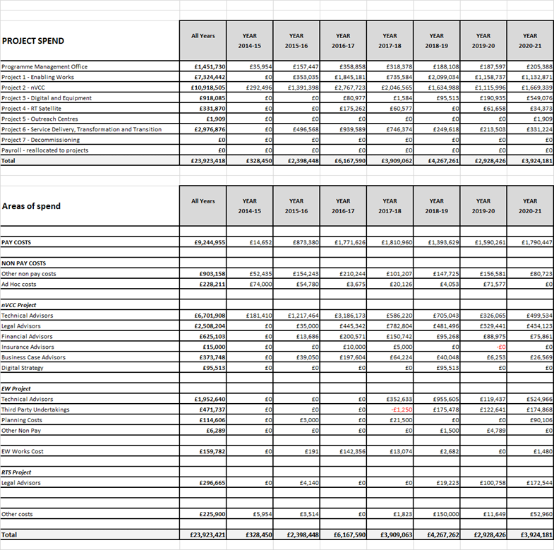
- Identification of the origin of the funding for the costs listed above, for example, if it is from the Trust's budget, or from additional government funding grants, etc
As at March 2021, the Minister for Health, Well-being and Sport, had approved capital and revenue funding for the TCS Programme and associated Projects of £20.710m and £1.678m respectively.
The remaining balance of c£1.535m has been provided from the Trusts budget.

I trust this answers your request for information, however, should you not be satisfied with the information supplied or the process of supplying it, you have a right to complain and request a review. You should forward your complaint to:-

Mr Stuart Morris
Chief Digital Officer
Velindre NHS Trust
2, Charnwood Court
Heol Billingsley
Parc Nantgarw
Cardiff / Caerdydd
CF15 7QZ
Tel / Ffon - 029 20196161

Should you wish to take your complaint further, if you are still unhappy with the decision after review, you can contact the:-

Information Commissioner's Office - Wales
2nd Floor,
Churchill House,
Churchill Way,
Cardiff,
CF10 2HH
Telephone: 029 2067 8400
fax: 029 2067 8399
email: wales@ico.gsi.gov.uk

Yours sincerely

Julie Mann
Communication and Compliance officer
Velindre NHS Trust
2 Charnwood Court
Heol Billingsley
Parc nantgarw
Cardiff
CF15 7QZ

