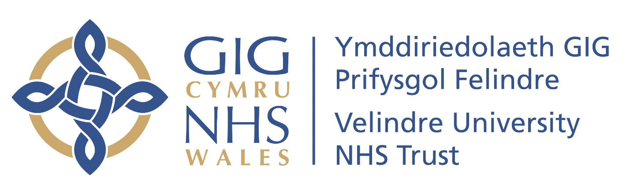

Equality at the heart of everything we do.

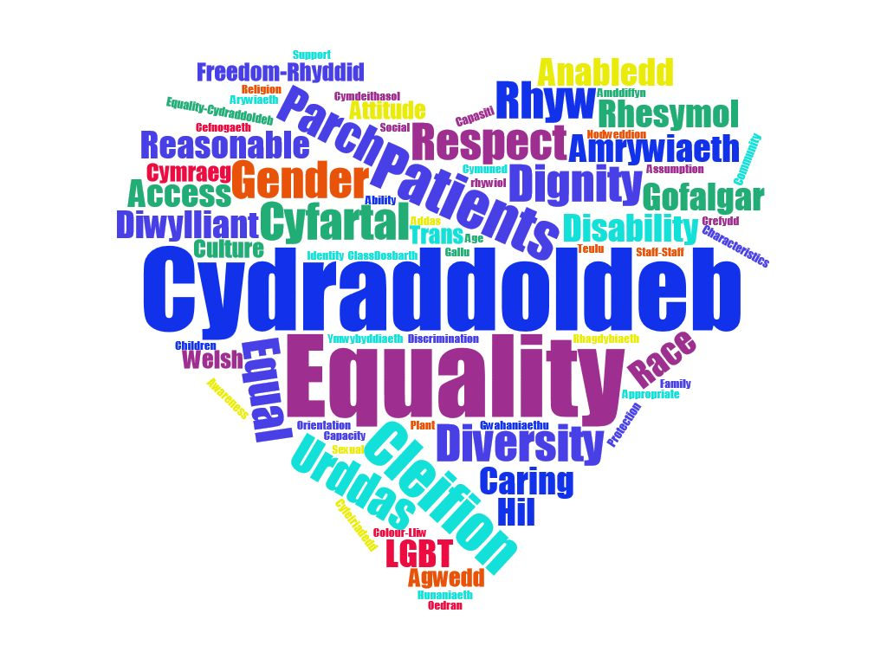

Strategic Equality Objectives & Plan 2020-2024
Foreword
Welcome to our third Strategic Equality Plan. We believe this plan demonstrates our continuous commitment to promote and deliver equality, diversity and human rights in all that we do. The Trust has always strived to demonstrate its commitment to ensuring equality for everyone as a provider of health care services and as an employer.

The Trust has seen over the last few years the growing challenging facing the NHS as it responds to unprecedented service pressure, new medical technologies, a changing workforce and different health issues. We have had to adapt our services and move to work hand in hand with our community, its public services partners, our volunteers and our employees to ensure Velindre University NHS Trust continues to provide a high standard of care and services ensuring we meet our commitments to deliver quality, care and excellence.

The Trust recognises that for positive changes to happen within our Trust and the wider society we need to identify the barriers that exist to access services, infrastructure, socio economic impact and diverse workforces and work together in partnership to remove those barrier so we all have equality of outcome.

So in developing this plan Velindre has joined together in partnership with other public bodies. A collaboration not just with health bodies, but art, culture, education and sport, gaining wider perspectives, providing inclusive collaboration and visibility with our communities.

This plan acknowledges the evidence and recommendations in the Commission for Equality and Human Rights report, Is Wales Fairer? and aims to incorporate the recommendations into its plans, both within the SEP and key Trust documents such as the Integrated Medium Plan (IMTP) and Trust Strategy.

The Trust believes that equality is about providing personalised care based on an individual's needs. It is about treating everyone with the dignity and respect. Ensuring that we communicate effectively, meeting individual needs and our services are accessible.

The Trust would like to thank everyone who has taken the time to provide their views, ideas and feedback. It has shaped our priorities for action and forms the basis of our objectives within our Action Plan.
Signed

Donna Mead OBE FRCN Steve Ham
Chair Chief Executive

What are Strategic Equality Objectives?
As part of our specific duties Velindre University NHS Trust is required to develop and publish its strategic equality objectives every four years. These objectives set out the strategic priorities of the organisation, focusing on how the Trust can contribute to a fairer society, advancing equality and good relations. The objectives should be specific and focus on one issue at a time.
- What does the Trust want to accomplish?
- What is not working?
- How can things improve?
Our Drivers
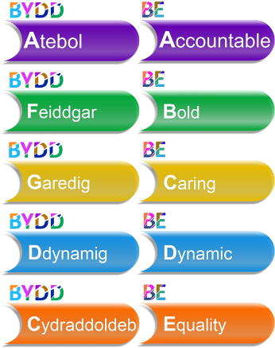
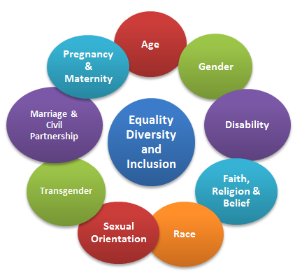
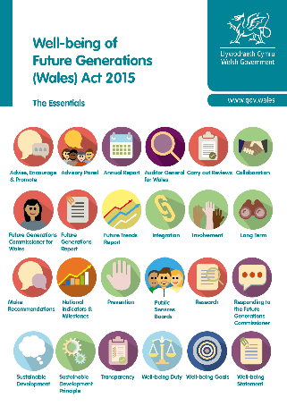
,

Protected Characteristics
Wellbeing of Future Generations
Trust Values

How were these objectives developed?
The Trust adopted a collaborative approach to the development of its objectives, recognising that a focusing on health alone will not meet the diverse needs of the people we employ, who use our services and society as a whole and that to support an inclusive diverse society we need to look at all areas from public, private and third sector and the only way to do this is in partnership.
Over the past year Velindre has been a partner with 11 other public bodies, together through public engagement we have identified 5 shared objectives. The Trust has included a further objective around ensuring communication needs. The shared Public Bodies SEP is included to the Trust SEP via Appendix 1. In addition Velindre has collaborated with Cardiff & Vale University Health Board on health focused engagement at public and community events such as the Cardiff Mela, BAME Health Fairs, Carers Wales Meetings and Learning disability events to ensure involvement and collaboration in all health matters is shared.

Translating our Objectives into Actions and Tangible Improvements
Hosted Organisations: strategic priorities & strategy

Trust Vision
Equality to be at the heart of what we do.
Velindre Cancer Centre:
Strategic priorities & strategy
Welsh Blood Service: strategic priorities & strategy

Velindre University NHS Trust Strategic Equality Objectives 2020-2024 IMTP: 2020 - 2023
Enabling legislation, strategies & plans

Trust Strategy IMTP
Doing Well, Doing Better HealthCare Standards How Fair is Wales
All Wales Standards for Communication and Sensory Loss Gender Pay Duty
Well Being of Future Generations Prosperity for All: the National Strategy
Socio Economic Duty Prudent Health and Care Taking Wales Forward (2016- 2021)
Public Health Wales Act (2017) Social Services and Well- being Act (2014)
Nurse Staffing Wales Act (2016) NHS Wales Blood Health Plan
Equality Act (2010) Welsh Language (Wales) Measure (2011)
Working Differently- Working Together: Workforce and OD Framework

Improved Outcomes and Benefits

What have we done so far.
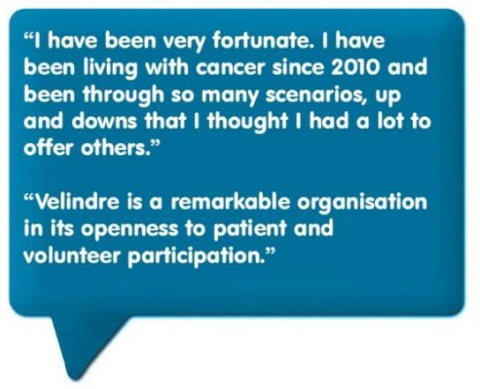
Patient and Community Leadership Programme: the Trust continue to deliver it’s VCC Patient Leadership Programme. Through collaboration with Public Health Wales and The Centre for Patient Leadership, 10 Patient Leaders were recruited. Who are now using their newly acquired leadership skills to help shape our services, influence change and share their own expertise with clinical staff. This was the first programme of its kind in NHS Wales, we are incredibly proud to be leading the way in our collaborative approach.

The Trust put together a 12 month programme looking at Gender in a wider context. For example the impact of banter in the workplace, how behaviours such as Hubris impact on confidence, exploring gender identity, labels and social barriers due to gender, right down to looking at the gender pay gaps that exist in our organisation. It was an opportunity to reflect, improve awareness and identify better ways of working together. The 12 month sessions concluded with a International Women’s Day event held in partnership with Unison.
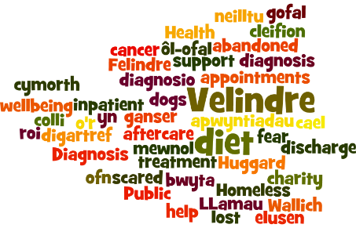
Homelessness & Cancer: Over the past few years we have seen an increase in the number of patients who have experienced different levels of homelessness, from hidden homeless, where relationships may have broken down and one partner is unable to afford to find alternative accommodation, to sofa surfing, living in temporary housing or hostels to rough sleeping. Each brings additional stresses and challenges to someone with a cancer diagnosis. In August 2019 the Trust held an event with LLamau, The Huggard and The Wallich to look at what the issues facing these communities and what Velindre can do to ease the stress and anxiety and provide support working on a multiagency level to provide wrap around care.

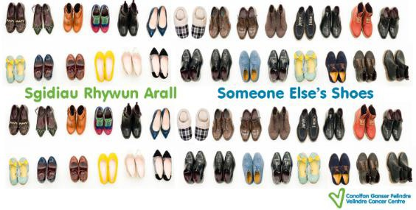
Velindre’s audio podcast Someone Else’s Shoes has continued to highlight patient, carer and staff perspectives this year. The podcast aims to increase understanding and enable learning opportunities for improvement and awareness.

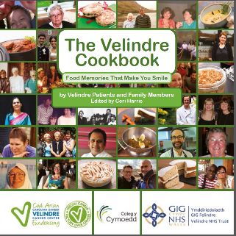
Patient and Family Member Cookbook: The charity cookbook has been developed in collaboration with our patients, their families and those impacted by cancer. The book includes tips on adaptations that can support someone going through cancer treatment. To promote inclusivity, the book is available in English, Welsh, written and audio was provided by RNIB and acclaimed chefs have taken part in British Sign Language cooking videos.
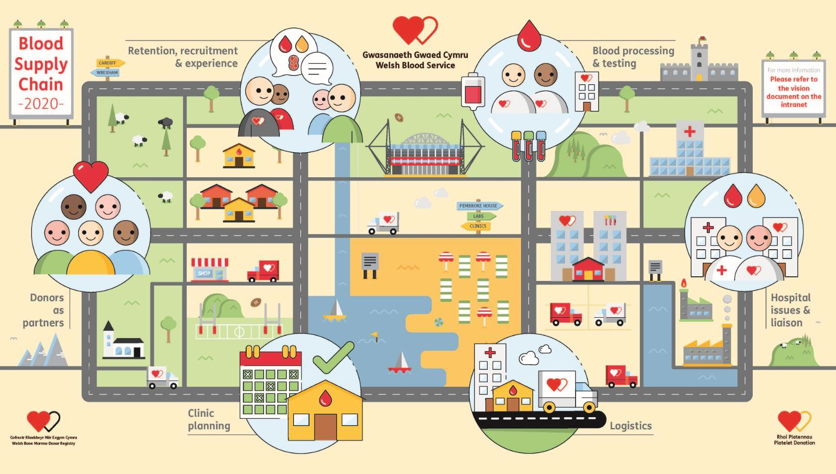
The Welsh Blood Service has daily interactions with members of its community of donors as well as diverse communities in Wales, building close links and partnerships with community groups, sports teams, businesses, education providers and other socially engaged groups that have an influence in their localities. Committed to listening to our donors, via face to face and by providing a comprehensive survey to every donor that enters a donation session each month. Also having a presence at events such as the National Eisteddfod, Cardiff Mela and BAME Health Fairs.

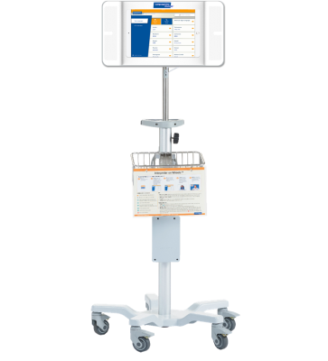

Interpreter on wheels: Velindre Cancer Centre introduced a new Video Relay Service called Interpreter on Wheels in 2019, which provides real time video interpretation services, from British Sign Language to other community languages. This service can be used in emergency situations, e.g if an interpreter has not turned up to assist a patient, in patient conversations when an interpreter has not been booked and if a patient come in without an appointment etc. An interpreter should always be booked for a known appointment. It is hoped that this service can also be used in other areas of the Trust in the future.

Staff Networks and Awareness Events: The Trust provides 3 Staff Networks, LGBT+, BAME and Staff with Disabilities or impairments. Each network is also supported by Allies. So that they are as assessable as possible each group is run at 3 different locations across the Trust, to have a minimal impact on business and clinical needs. Attendance to the network meetings is protected and staff within the networks are invited to develop and support inclusive initiatives such as Black History Month, Sensory Loss Awareness Month and LGBT+ History Month.

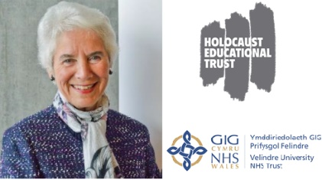
These have included events such as screenings of the BBC Documentary, “How Black Nurses Saved the NHS”, Taking part in Pride parade each year, Sensory Loss Awareness events and interfaith visits. In January the Trust invited Eva Clarke BEM to give her story about being born in a concentration camp. Looking at how we all have a role to play to ensure that hate and prejudice is challenged.
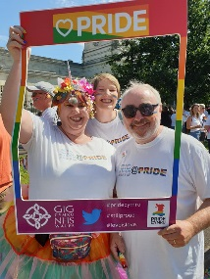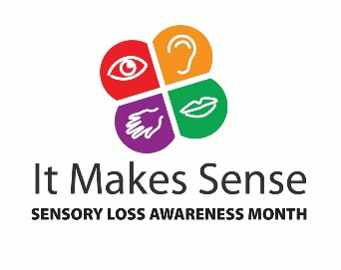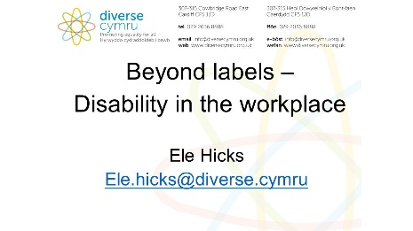

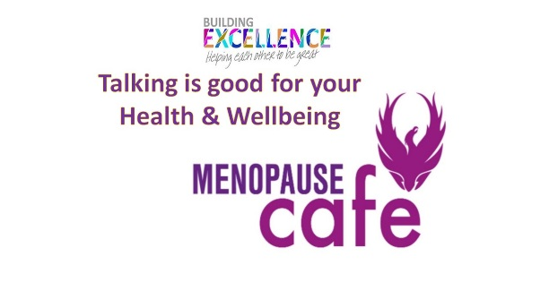
Menopause Policy & Workplace Café’s: The Trust introduced a Menopause Policy as it recognised how the menopause had been impacting staff across all services. Alongside this support sessions called Menopause Café’s were held. The concept behind the Menopause Café was the brainchild of Rachel Weiss from Rowan Consultancy who was keen to remove some of the barriers that have so often made the menopause an uncomfortable and off-limits subject for discussion for so many women and their families. Velindre first workplace organisation in Wales to sign up to the Menopause Café which is open to all genders and ages, recognising that menopause impacts on us all, therefore increased awareness and support is vital. Initially the cafes held in Velindre were just for staff, but it was recognised that the concept of support would also benefit our cancer patients and their families who might be experiencing menopause as a consequence of their treatment.

RiTTA (Realtime information Technology Towards Activation) – The World’s First Virtual Assistant Trained in Oncology : Supporting patients as they live with cancer is a key requirement for a cancer center. Over the past 2 years, Velindre Cancer Centre has been having meaningful conversation with patients, carers and their families about how best to support their information needs and their desire to want to have a measure of control, empowerment and independence as they make their care choices. A key area of need was the gaps in between existing services and the lack of tools for patients to have good quality conversations, at any time or place and access to relevant quality information to support their choices and decisions about their emotional, psychological and physical wellbeing. This included the need to incorporate diversity, from understanding language needs, including text type speech to ‘thinking’ outside the heteronormative base with regards to relationships and gender identity.
Through a person centred, design thinking process, Velindre in conjunction with Pfizer Oncology and IBM Watson have developed the world’s first Artificial Intelligence (AI) enabled virtual assistant trained in oncology to proof of concept. This dialogue agent is currently trained to answer a small number of ‘patient related queries’ to demonstrate capability.

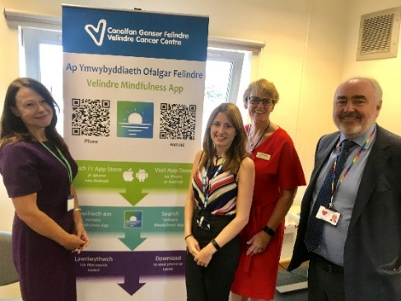
Velindre Mindfulness Ap: The Trust has developed a Mindfulness App to provide guided mindfulness and relaxation exercises aim to improve mental health and wellbeing before, during or after hospital treatment. The App is deliberately non-cancer specific so that anyone can use mindfulness as a tool to manage stress and anxiety. There is also a relaxation element to the App which has been provided courtesy of the Occupational Therapy team here at Velindre. The app is designed to walk listeners through mindfulness practice, gain an understanding of how mindfulness works and give some insight into how it can be used to handle real life situations more effectively.

How will we know if the Trust has met its objectives and improved?
The Trust publishes within the Trust Annual report, progress it has made on each objective, and on the actions that have been identified within the Equality Scheme Action Plan.

To ensure progress of each of the objectives, the Trust Equality Scheme Action plan will be monitored internally by the Trust Quality and Safety Committee on a quarterly basis, which in turn reports to Trust Board. In addition to this the Patient Liaison group and external stakeholders will be provided with status reports bi-annually. This report will also be made available on the Trust website.
The public is welcome at any time to comment on any aspect of the objectives or scheme and action plan.

Each year the Trust is required to complete the Health Care Standards, “Doing Well, Doing Better”. Equality and Human Rights evidence is required during this process and the outcomes of the Health Care Standards are published annually.

Do you have any comments?
The Trust values all feedback positive and negative that will enable us to improve our services.
By Post;
Equality and Diversity manager
Velindre Trust HQ
2 Charnwood Court
Parc Nantgarw
Cardiff
CF15 7QZ

By Email;
Ceri.Harris3@wales.nhs.uk

Equality Objective | Link to | Action | Intended Outcome By 2024 | Outcome Measure | Protected Characteristic or Wellbeing Goal
1. Increase workforce diversity and inclusion | How Fair is Wales?  Integrated Medium Term Plan  Doing Well, Doing Better  HealthCare Standards  Gender Pay Duty  Public Bodies Shared Objective | Workforce Planning to include work placements and apprenticeships, working with community groups and 3rd sector.  Achieve Level 3 Leader for Disability Confident. Workforce group to be established to progress.  The Trust to submit its response to the Stonewall Workplace Index annually.  Staff Networks to take a role in policy development.  Velindre to lead on the development of an All Wales NHS Rainbow Badge Scheme.  Alignment of employment data reporting.  The Trust promotes and provides awareness sessions, information, training and workshops for key awareness events such as Carers Week, Black History Month, LGB History Month and Sensory Loss Awareness Month.  WBS – engage with North Wales equality based groups to improve take up  WBS – Review data categories to look at accurate recording of gender to include transgender data. Recognising that MX is already available.  Analysis of staff equality data to assist in identifying actions if pay gap exists or a need for specialist training and positive action programmes.  Involve more patients and carers in work to improve their experiences  Deliver improved engagement with donors, citizens & organisations in shaping our services. | Improve levels within ‘Doing Well, Doing better’ to ensure better health outcomes and dignity for all  By 2021 achieve Leader in Disability Confident programme.  By 2021 the All Wales Rainbow Badge scheme and training will be developed and rolled out across the NHS.  By 2024 the Trust will be identified in the top 100 Stonewall Workplace Index.  By 2022, we will have aligned our own employment data reporting to match that of the Welsh Government in both format and reporting dates.  By 2024 we will have evidence of how we reach out to minority groups and those living in poverty to gain employment with us.  By 2021 Review patient engagement activity and revise strategy for existing services and future developments within TCS programme and establish revised tools and techniques  Review the ways of working of the Patient and Carer Liaison Group  Develop and implement a scheme to identify and support inpatients with additional needs.  Improve information resources available to people affected by cancer  By 2021 implement new customer service standards for blood donors and bone marrow volunteers.

Equality Objective | Link to | Action | Intended Outcome By 2024 | Outcome Measure | Protected Characteristic or Wellbeing Goal
2. Eliminate pay gaps | How Fair is Wales?  Integrated Medium Term Plan  Doing Well, Doing Better  HealthCare Standards  Gender Pay Duty  Public Bodies Shared Objective | Ensure all new positions undergo job evaluations  Workforce and O D to look at Talent Management and succession planning  Ensure all staff receive Personal Development Plans in a timely manner.  Support personal and professional development.  Analysis of Equality Monitoring information to identify possible support and training needs and develop positive action initiatives.  Review staff survey responses to measure improvements. | Accurate data across the public sector which provides analysis across protected characteristics.  Improved staff feedback and experiences  Potential decrease in staff absence and staff turnover.  Decrease in grievances

Equality Objective | Link to | Action | Intended Outcome By 2024 | Outcome Measure | Protected Characteristic or Wellbeing Goal
3. Engage with the community. | How Fair is Wales?  Integrated Medium Term Plan  Doing Well, Doing Better  HealthCare Standards  Transforming Cancer Services  All Wales Blood Service  Public Bodies Shared Objective | Equality and dignity themes collected from monthly patient surveys  Partnership project -  All Wales Blood Service to work with community groups, to improve awareness and increase donations  Work in partnership with LHBs, CHCs and the 3rd Sector to identify need and patient and donor experiences.  Take part in community events such as Health Fairs, Pride and 3rd Sector events.  Deliver transfusion education across Wales | Improved Patient/donor Access and Experiences  Better Health Outcomes for all  By 2021 engagement video to be competed from project and published.  By 2024 we will be able to demonstrate and evidence co-production of our strategies, policies, service changes and decisions  By 2022 deliver Blood Health Education Strategy, facilitated by BHT with delivery by end users.  Deliver revised NABT Programme under new commission agreement

Equality Objective | Link to | Action | Intended Outcome By 2024 | Outcome Measure | Protected Characteristic or Wellbeing Goal
4. We communicate with people in ways that meet their needs (whether this is via written communication, face to face, signage, Welsh or other community languages including British Sign Language) | All Wales Standards for Accessible Communication and information for people with Sensory Loss.  Integrated Medium Term Plan  Transforming Cancer Services Programme  All Wales Blood Service Programme  Welsh language Standards | Improve collection of language information and communicate effectively with patients, their carers, donors and families in the language of their choice.  Interpreter on Wheels programme to be available on additional mobile devices, laptops throughout the Trust.  Explore potential for this technology to be used in Welsh Blood donor settings.  Access Matters group – improve all areas of access and communication at VCC including signage.  RiTTA – development of inclusive communication and diverse cultural intelligence.  WBS – Engagement programme with North Wales Equality Group  Provision of 21st Century Digital Services for donors. | By 2024 a measurable improvement in recorded, (facec to face, survey etc) Improved Patient/donor Access and Experiences  By 2024 demonstrable evidence of the inclusion of Artificial Intelligence and Digital technology into accessibility needs such as sensory loss support, learning disability and socio economic disadvantage. IBM to look at BSL interpretation.

Equality Objective | Link to | Action | Intended Outcome By 2024 | Outcome Measure | Protected Characteristic or Wellbeing Goal
5. Ensure service delivery reflects individual need. | How Fair is Wales?  Integrated Medium Term Plan  Doing Well, Doing Better  HealthCare Standards  Gender Pay Duty  Public Bodies Shared Objective | Involvement of community groups, organisations and individuals in the final design of the new hospital.  Inclusive access, from services, public transport, use of technology and physical environment.  Ensure all new blood donation session venues are accessible and revise current venues for accessibility.  Work in partnership with LHBs, CHCs and the 3rd Sector to improve accessible healthcare.  Support personal and professional development.  The Trust has developed and Integrated EQIA process, that includes Wellbeing of Future Generations Principles, Welsh Measure, Socio Economic Duty and positive action, this will be evaluated over the first 12 months.  Policy development and procedures in place to provide support and safeguarding to patients who come under the umbrella term of homeless.  Redesign patient pathways to improve flow, patient experience and capability.  Develop strategic plan for extended hours/days of service to facilitate increased capacity or to meet increase in demand ensuring alignment with the Satellite RT service and wider Transforming Cancer Services clinical model.  In collaboration with Cardiff and Vale UHB, develop an integrated cancer PrehabilitationService | By 2024, collective evidence of engagement and involvement of development of the new hospital.  By 2024, we will be able to evidence operational systems and ways of working that ensure individual needs are understood and respected whilst accessing and receiving services.  By 2024 we will have collaborative systems in place for co-producing.  By 2022 a framework for adopting and sharing good practice  Business case to be submitted to charitable funds to support pet care for homeless and vulnerable patients. Working with local charity to provide pet care service such as dog sitting to enable homeless patients to attend appointments, treatment and care.  By 2021 a scoping project to look at provision of food vouchers for patients carers and family members in need. To include food bank access. Outcome of project to then look at funding options.  By 2024  Demonstrate Contribution towards  achieving the Single Cancer Pathway  Improved efficiency  Outpatient clinic utilisation rate of 85% by 2022  Improve Proms/Prems for Therapies  Improve waiting times  Improve patient experience  Improve staff experience and wellbeing.  By 2023 the opening of the Satellite Unit.  By 2021 develop and establish a proof of concept model with C&V UHB  Commence implementation on phased approach for 3 tumour sites

